USAID GLOBAL HEALTH SUPPLY CHAIN PROGRAM
Procurement and Supply Management

National Product Catalogue (NPC)
Product Master Data Management
Standard Operating Procedure (SOP)

Version 1
December 2020
Table of Contents
Acronyms iv
1 Background 1
1.1 The Product Catalogue management Tool 1
1.2 Standard Operating Procedure 1
2 Key Concept Overview 2
2.1 GS1 Standards 2
2.2 Products & Trade-Items 3
2.2.1 Product-Item Hierarchy 3
2.3 PCMT Structure & Terminology 4
3 NPC Processes 5
3.1 Accessing the NPC 5
3.1.1 Logging In 5
3.1.2 Recover Your Password 5
3.2 Dashboard & Activity Summary 6
3.2.1 Dashboard 6
3.2.2 Catalog Volume Monitoring 6
3.2.3 Process Tracker 7
3.2.4 Drafts 7
3.3 View Product Data 8
3.3.1 Product Grid & Filtering 8
3.3.2 View Product Attributes 10
3.4 Adding a New Product 11
3.4.1 Process Overview 11
3.4.2 Adding Items to the NPC 13
3.4.3 Approving New Products 14
3.5 Adding Product Models 15
3.5.1 Creating Product Model 15
3.5.2 Approving a Product Model 16
3.6 Creating Associations (Mapping) 17
3.6.1 Adding Associations 17
3.6.2 Approving Associations 19
3.7 Editing Products/Items 20
3.7.1 Editing a Product/Item 20
3.7.2 Approving Edited Products/Items 23
3.8 Deleting or Deactivating Products/Items 23
3.8.1 Process Overview 23
3.8.2 Deleting a Product/Item 24
3.8.3 Deactivating a Product/Item 25
3.9 Data Import & Export 27
3.9.1 Import Data 27
3.9.2 Export Data 28
3.9.3 Key Import/Export Profiles 29
4 System Administration & Configuration 30
4.1 Roles and Responsibilities 30
4.1.1 National Product Catalogue Manager 30
4.1.2 System Administrator 31
4.2 User Management 31
4.2.1 Creating User Roles 32
4.2.2 Creating User Accounts 37
4.2.3 Creating User groups 39
4.3 Product Attributes 41
4.3.1 Attribute Types 42
4.3.2 Creating Attributes 42
4.3.3 Grouping Attributes 45
4.4 Create Categories 47
4.4.1 Create Sub-Categories 49
4.5 Manage Import & Export Profiles 50
4.5.1 Import Profiles 50
4.5.2 Export Profiles 53
5 Data Collection 55
5.1 Data Sources 55
6 Appendices 57
6.1 Appendix 1 PCMT Installation 1.0 User Documentation 57
6.2 Appendix 2 Catalogue Manager Job Description 58
6.3 Appendix 3 Letter to Manufacturers 60
6.4 Appendix 4 GS1 Data Upload Extract 61
6.5 Appendix 5 Data Collection Form 62
7 Annex 63
7.1 Annex 1. Mobile Application Deployment & Configuration 63
7.1.1 Signing up for services 63
7.1.2 Creating PCMT Connection in PCMT 63
7.1.3 Fork the application repository 64
7.1.4 Create a JSON Blob 64
7.1.5 Creating application signatures 64
7.1.6 Create an application build 65
7.1.7 Distribute Application 65

Acronyms

CMST Central Medical Stores
ERP Enterprise Resource Planning System
GFPVAN Global Family Planning Visibility and Analytics Network
GPC Global Product Classification
GS1 Global Standards 1
GTIN Global Trade Item Number
JSON JavaScript Object Notation
MDM Master Data Management
MoH Ministry of Health
NPC National Product Catalogue
OpenHIE Open Health Information Exchange
OpenLMIS Open Logistics Management Information System
PCMT Product Catalogue Management Tool
PIM Product Information Management
UI User Interface

Background
Global health supply chains lack visibility and traceability of products through the supply chain due to challenges in maintaining product master data. Often, product identifiers are inconsistent across systems and levels of the supply chain and tracking systems and product master data maintenance processes are highly manual. The lack of consistent, robust product master data management across systems hinders effective logistics management and interoperability between health information systems (HIS).
In response, the <Country> Ministry Health, with support from USAID, have implemented a National Product Catalog (NPC) application for <Country> . The NPC provides a central system for the country to standardize, maintain, and manage health product data. The system improves interoperability between systems that use product data - such as CSMT (ERP), OpenLMIS, and DHIS2 - by serving as the master source of product data using standard product codes and mapping capabilities. It also supports the implementation of global product identification standards such as Global Standard 1 (GS1) Global Trade Item Numbers (GTINs) and the mapping of global identifiers to <Country> -specific data (national product identification codes). The NPC allows all regulatory, operational, and planning stakeholders better visibility into product information as well as receive notification of any changes made to the product master data for review.

The Product Catalogue management Tool
The Product Catalogue Management Tool (PCMT), an open-source software that allows organizations to publish and manage product catalogs, was selected as the system for <Country> ’s NPC. PCMT is comprised of several modules added to Akeneo’s community edition - an open-source product information management (PIM) tool - designed to support LMIC countries to create and manage product catalogues using global standards such as GS1. PCMT helps health care supply chains work for everyone by facilitating product information management, master data management, and interoperability.
At the global level, donors and procurers can publish a master product catalog with common product identifiers, classification/ categorization, and manufacturer data sourced from GS1 GDSN. At the national/country level, adopters can ‘subscribe’ to any of the global catalogs and also add their own country products and add fields/metadata for their country needs, such as mappings to in-country legacy system identifiers.
PCMT streamlines health product data use, by enabling various players in the healthcare system to interact with the same data by providing a single source for product data and linking system-specific product identifiers to enable tracking across systems and providing increased interoperability. For additional background on PCMT see www.productcatalog.io.

Standard Operating Procedure
The National Product Catalogue (NPC) Standard Operating Procedures (SOP) have been developed to aid users, administrators, and key stakeholders who use and manage health product data in PCMT and across systems. These users include Ministry of Health and warehouses with ERPs/WMS, Ministry of Health, and District Hospitals using OpenLMIS, among others. This document describes and illustrates key processes related to management of product master data in the NPC.

Key Concept Overview
This section provides an overview of key concepts and terminology for health product master data management and using the NPC.

GS1 Standards
GS1 aims to improve the efficiency, safety and visibility of supply chains across physical and digital channels by provide standard business language that identifies, captures and shares key information about products, locations, assets and more. GS1 organization provides specifications for the identification of products and entities in a supply chain and capturing and sharing data about those products to enable traceability and data visibility through global attributes utilized by many partners in a supply chain. The adoption and use of GS1 standards is in progress in <Country> to facilitate product master data management. The NPC supports the use of GS1 identifiers to ensure standard, accurate product data is available across health systems and platforms. A few of the most critical GS1 identifiers relevant to the NPC are described in this section (see GS1 Fundamentals for additional information).
- GTIN - A global trade item number (GTIN) is the basis of much of the GS1 system of standards. GTIN’s are used to uniquely identify a brand owner's / manufacturer's product. Items identified could be physical items, like tablets of an antibiotic, or services, such as surgical procedures. It’s important to note that the organization that assigns or creates a GTIN is the one that owns the brand, holds the IP, or produced the item.
- GLN - A global location number (GLN) is used to identify locations or legal entities. The simplest application of these is to identify physical facilities, plants, or stores, though a GLN could also be used to identify dock doors, shelves, rooms, etc. depending on the need. The GLNs should be used, however, to identify physical locations (rather that a truck or pallet that may change locations).
- GDSN - Global Data Synchronization Network (GDSN) is a network of providers that help share master product data between producers and consumers. Product identifiers such as GTINs can be obtained through a subscription to the GDSN (though this is not the only possibility). GDSN providers can also provide additional services and information (such as pricing) on top of the core product attributes like GTINs. See Annex 1 for additional information on GDSN, other GS1 attributes, and terminology, and Annex 4 for additional resources.

Products & Trade-Items
In the context of the NPC, a product is a commodity with a set of defining characteristics according to the standard product definitions in the <Country> Master Health Product List (MHPL), maintained by CMST. The MHPL defines health products as generic commodities which are not specific to any manufacturer or brand and hence do not have a direct association with a specific individual physical commodity, but rather represent a grouping of various like items. These products include a generic description, a product identification code and other general information.
A trade-item (also referred to as an item or a branded-item) is a unique product specific to a manufacturer or supplier. These items are assigned unique identifiers, such as GTINS (for items with GS1 identifiers). In <Country> items are identified with GTINs, where available, or trade-item-specific identification numbers where GTINs are not available.

Product-Item Hierarchy
Products and items have a hierarchical relationship in which multiple items can be associated with a product. This hierarchy is also known as a parent-child relationship where multiple unique “child” items are associated to a “parent” product as defined by the MPHL. Figure 1 provides a graphical depiction of the generic product and associated unique trade-item and their parent-child relationship.
Figure 1: Product-Item Relationship Diagram

Product

Male Condom (Latex), 49 mm
Parent ID: 11000

Item

Male Condom (Latex) 49 mm
Lubricated, Generic Strawberry, 1 Each Innolatex
GTIN: 100941XXA01S01Q
Item

Male Condom (Latex) 49 mm
Lubricated, Aphaw Banana, 1 Each
Unidus
GTIN: 100934XXA01S03H
Item

Male Condom (Latex) 49 mm
Lubricated, No Logo, Case of 3000 Pieces Suretex
GTIN: 100932XXA0DA01X

The NPC provides the capability to define both product and item data as well as define the hierarchical relationship between various products and items.

PCMT Structure & Terminology
In addition to the product-item distinction and relationship, there are several key terms and concepts to understand in order to use PCMT and manage <Country> ’s NPC.
Table 1: PCMT Key Terms & Concepts
Term/Concept | Definition
Attributes | Attributes are data elements used to define product and item characteristics in the PCMT. There are various types of attributes (such as identifier, text, number etc.) that determine what type or format of data is valid for the particular attribute. Attributes can be added, changes, and required or optional depending on the standards and policies governing product master data management in <Country> .
Family | A family is a set of attributes used to define groups of products or items that share the same attributes. Families are used to set up the product model or structure for the NPC. When a product is added to a family, it inherits any attributes defined at the family level. A product can only belong to 1 family.  In <Country> , the NPC has 2 families: <Country> Products – the generic products defined by the MHPL; and <Country> Products and Trade Items – the unique, branded items that have item-specific identifiers such as GTINs.
Variant | A variant product is a product or item that shares common attributes with a product but also has unique properties. Variants can be set up a number of different ways based on the need. In the <Country> NPC the trade-items defined with GTINs are variants of the <Country> Products (MHPL).
Category | A category is used to classify products and items. A category can have multiple sub-categories and levels, which forms a category (or classification) trees. A product or item can be in several (or no) categories. In <Country> , categories include dosage forms, supplies, and programs. Categories can also be used to add GS1 global product classification (GPC) systems to the product catalogue.
Deletion | Deletion of a product or item involves the removal of a product or item and all related data from the catalogue.
Deactivation | Deactivation changes the status of a product or item from “Enabled” to “Disabled”. When deactivated, a product/item – and all relevant data – remains in the catalogue but is inactive. If the product/item needed to be re-activated in the future, the status can be updated to active, avoiding the need to add it and all the data again, as well as maintaining historical data.
Channel | A channel is used to define a selection of products and information to export that is linked to a category tree. It works like a filter on the product catalogue and can be used if there is a need define different content for the same attribute or different completeness. Currently the <Country> NPC uses only the Product Catalogue channel.

More detail on these concepts and others are available in the PCMT Wiki.

NPC Processes
This section provides an overview of the main operations and processes that will enable users to access and manage product data in the NPC.

Accessing the NPC
To access the NPC, go to <NPC URL> on a web browser (internet connection is required). You will see the log in screen for the NPC.

Logging In
To log in into PCMT you need to have username and password. Users are assigned roles and permissions which controls what functions and information a user has access to. The System Administrator creates user accounts, if you do not have a user account, contact the Administrator to have one created.
Figure 2: <Country> NPC Log In Screen
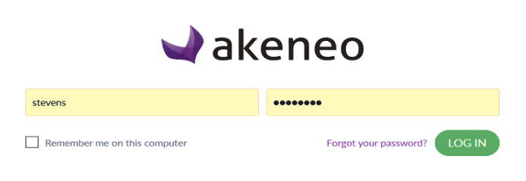
2
3
1

- Enter your username
- Enter your password
- Click LOG IN

Recover Your Password
If you enter your password incorrectly, you will see an error message stating that your credentials are invalid (as seen in Figure 3). If you have lost or forgotten your password, you can reset it by sending a reset link to the e-mail address associated with your user account.
Figure 3: Forgot Password
1
- Click on the FORGOT YOUR PASSWORD link

Figure 4: Password Reset Request
2
3
- Enter your e-mail address in the text bar
- Click REQUEST

After you click request, you will receive an e-mail with a link and instructions to reset your password. The system will only allow users to request a password reset once in a 24-hour period.

Dashboard & Activity Summary
When a user logs in to the NPC, they will see the dashboard in the Activity section. The dashboard provides an overview of the catalogue data, activity, and drafts that can be reviewed in more detail in their respective sections.

Dashboard
In the Activity section, the dashboard provides an overview of the information and product data structure in the NPC (1). It also gives brief systems processes tracking (2) and activity monitoring information (3).
Figure 5: Dashboard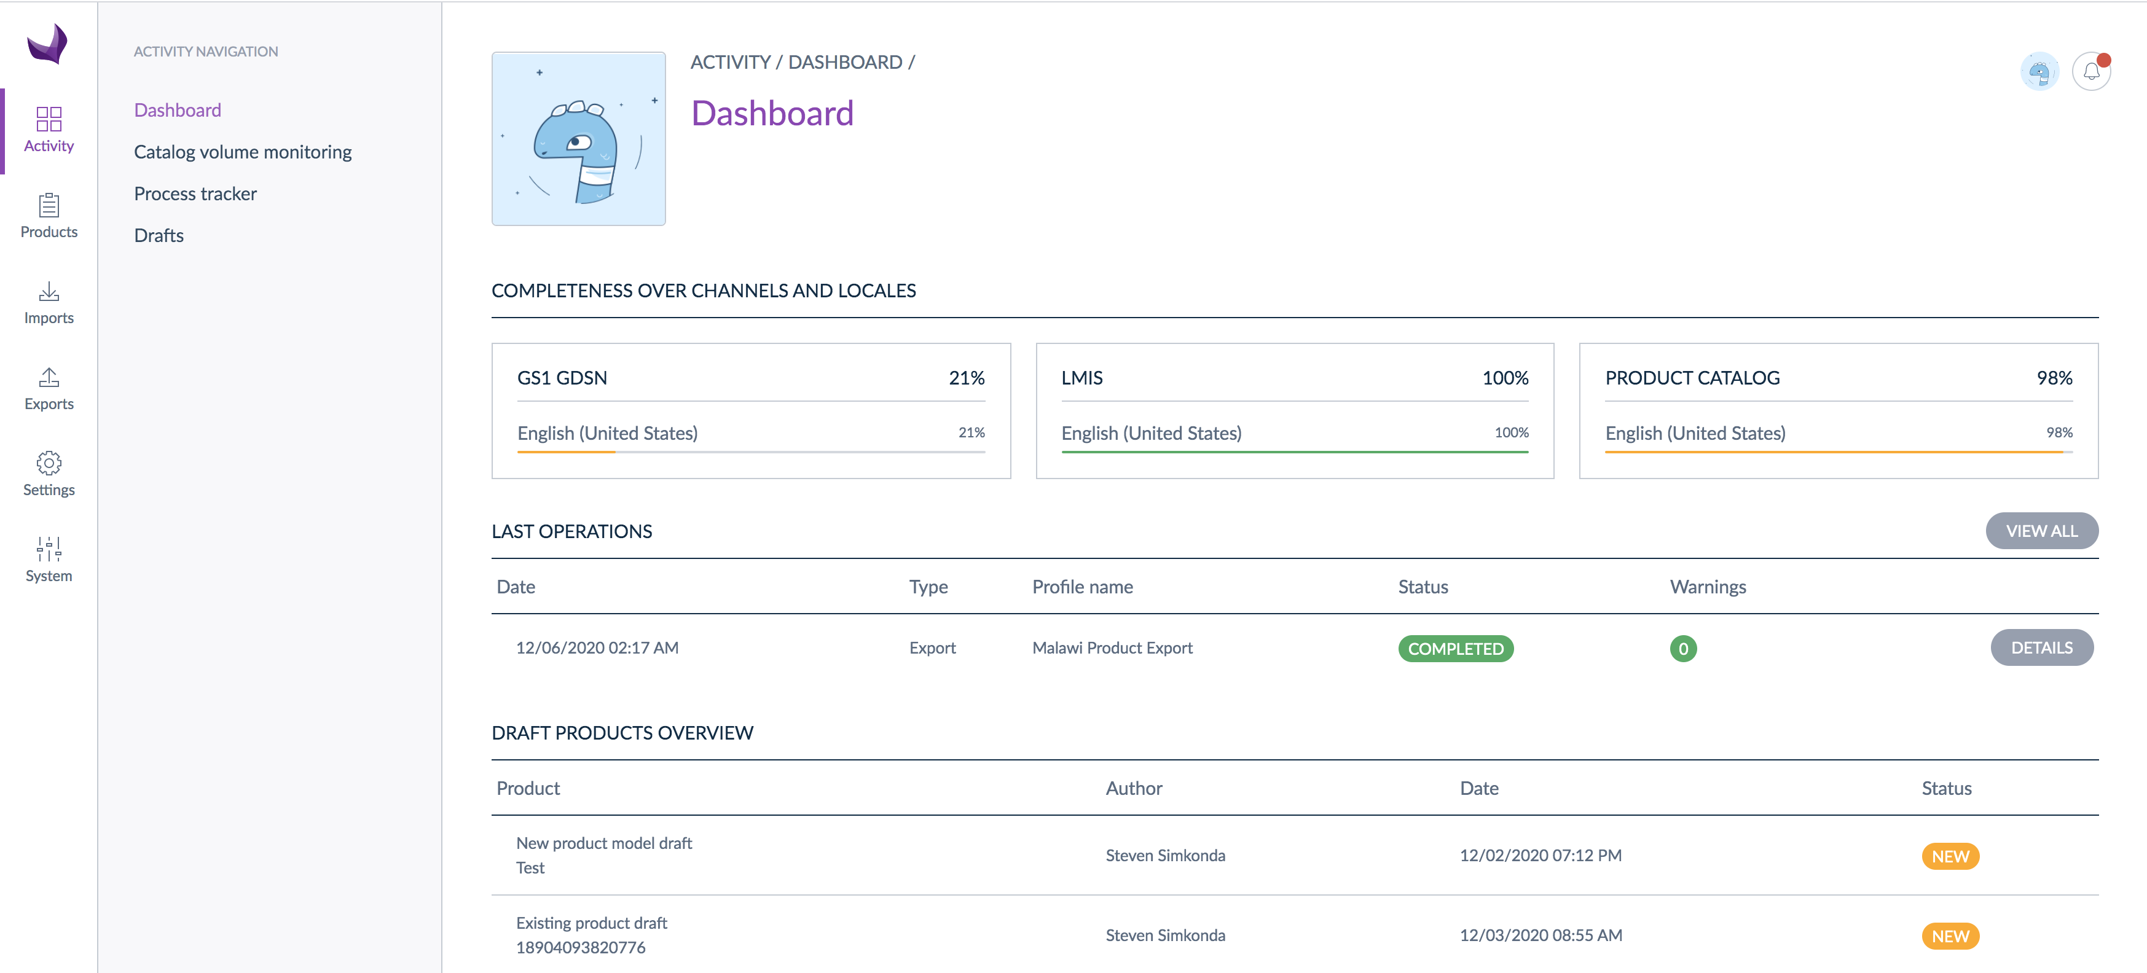
1

2

3

Catalog Volume Monitoring
The catalog volume monitoring section provides the total number of product values and groupings in the NPC holds, including number of products, families, categories, attributes, etc. These data provide information about the extent and value of the information contained in the product catalogue.
Figure 6: Catalog Volume Monitoring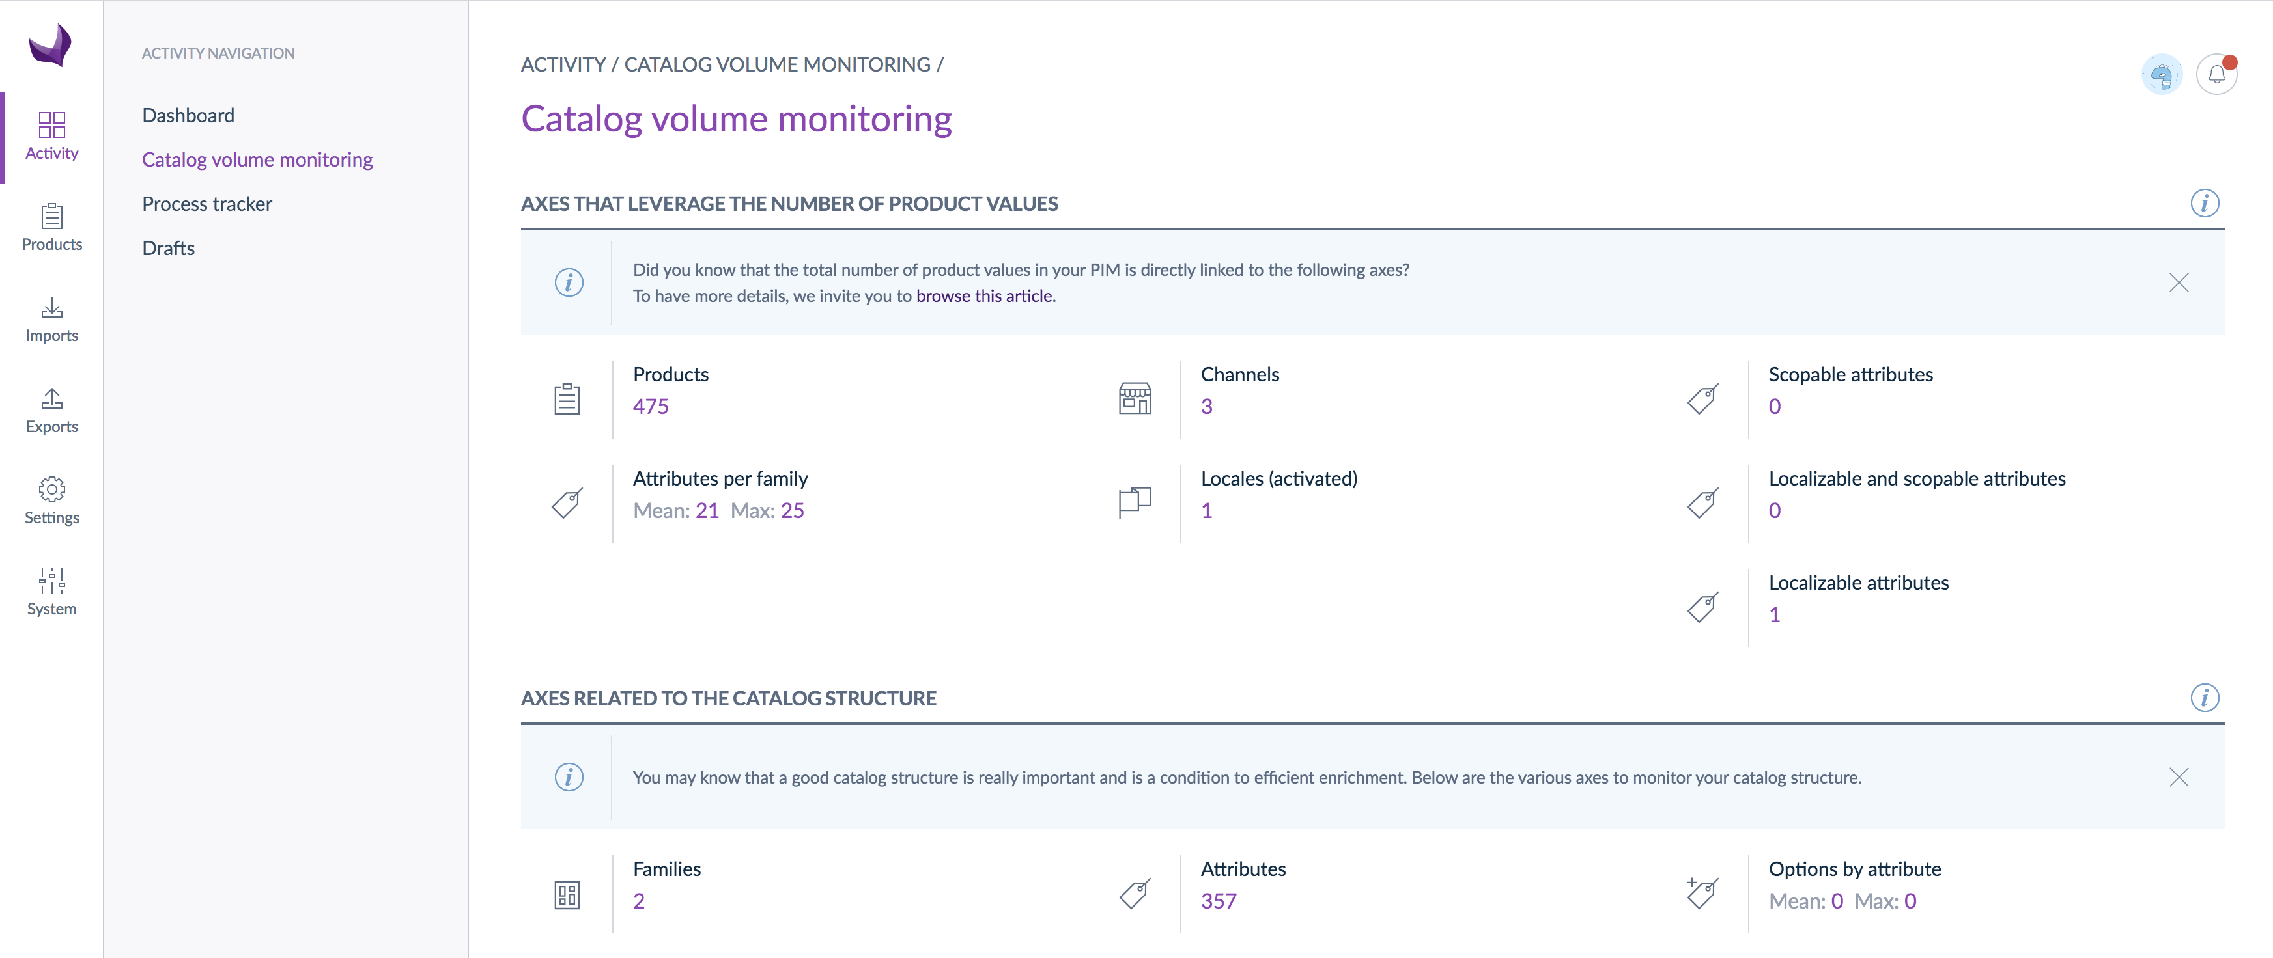

Process Tracker
The process tracker provides a full list of all action/activities done by a user on data, such as data imports or exports.
Figure 7: Process Tracker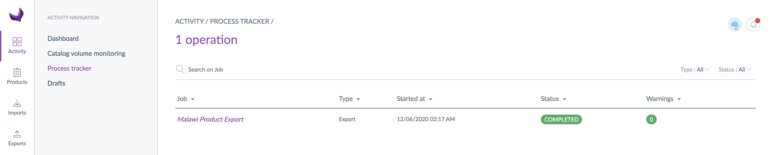

Drafts
The drafts section shows all product/item data that is in a draft state – new or updated information that is waiting for approval before it is finalized. Any changes made to data in the system starts at a draft status and will stay in drafts until approved by the designated personnel. The details of these changes are shown on the draft page:
Figure 8: Drafts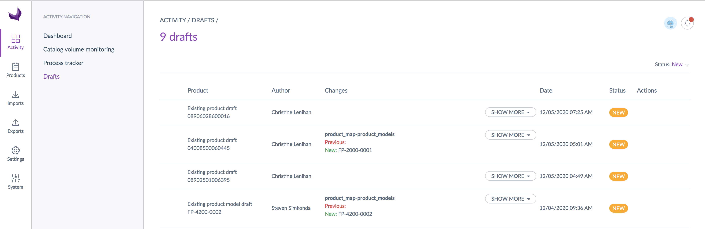
1

4

3
2
6
5
- Product details
- Author (user) of the changes
- Changes that were made
- Date of changes
- Status of the draft
- Actions – depending on your user permissions you may be able to edit, approve, or reject the draft (see section 3.4.3 for more detail).

View Product Data
The NPC data can be viewed in more detail in the Products section.

Product Grid & Filtering
The NPC has various filters to allow users to navigate the data efficiently to find and view specific product(s) or item(s). Each filter consists of options that you can choose from to specify what data you want to show in the product grid. By default, the system will show results for all products/items. You can use filters to narrow down the information that is displayed; for example, to view only the master product (MHPL) data, you could filter the data to see only one family. This section provides an overview of the product grid and use of filters. Additional details and information can be found on the Help Center.
Figure 9: Product Grid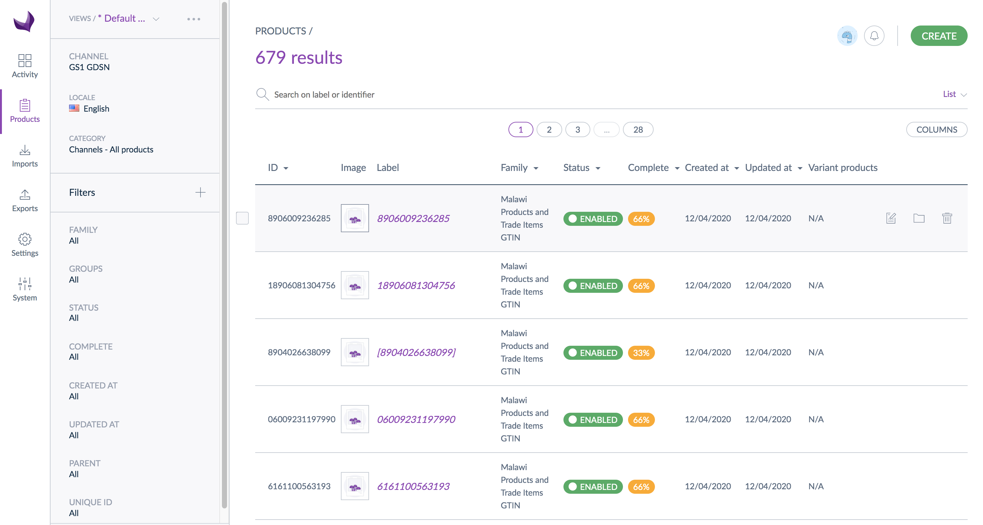
1
2
3
- Click on PRODUCTS on the far left sidebar
- The filters will display to the left of the product grid
- Click on a filter (ex. FAMILY) to set the filter
Figure 10: Set Filters
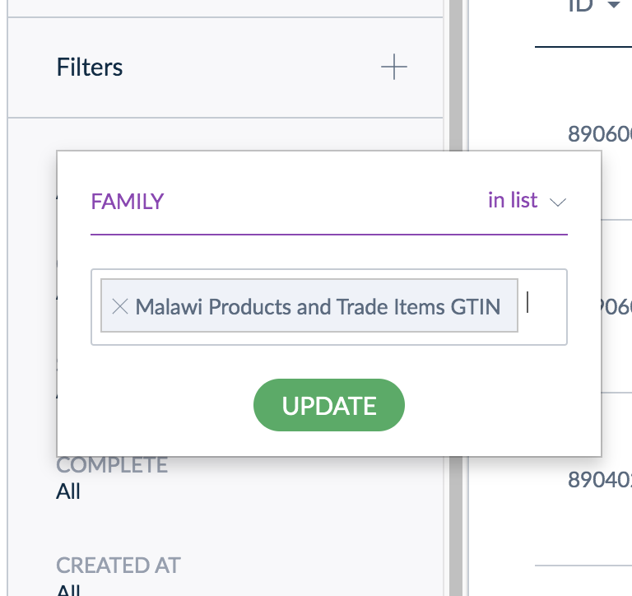
4
5

- Select the filter option (ex. <Country> Products and Trade Items) from the available options
- Click UPDATE to apply the filter

Users can also add or remove the filters available in the left side bar:

Figure 11: Adding/Removing Filters
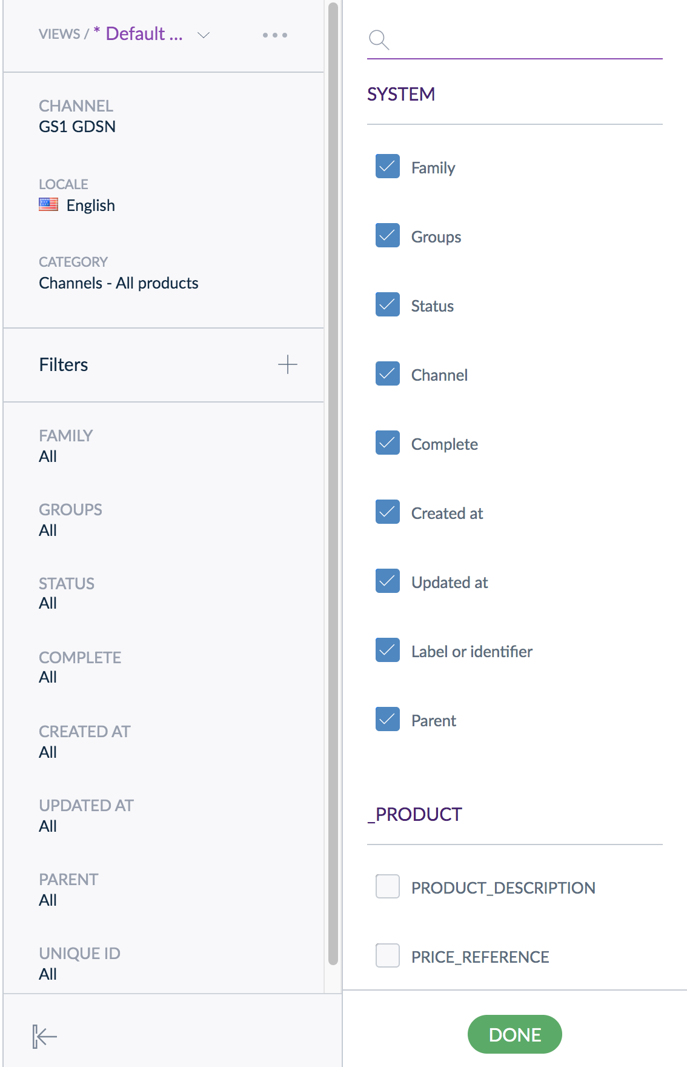
1
3
2

- Click + next to Filters
- Check or uncheck the selection boxes next to the filters to add (selected) or remove (unselected) them.
- Click DONE to apply the changes

View Product Attributes
To see all the specific data for a product/item, simply click on that entry from the product grid.
Figure 12: Product/Item Selection from Product Grid
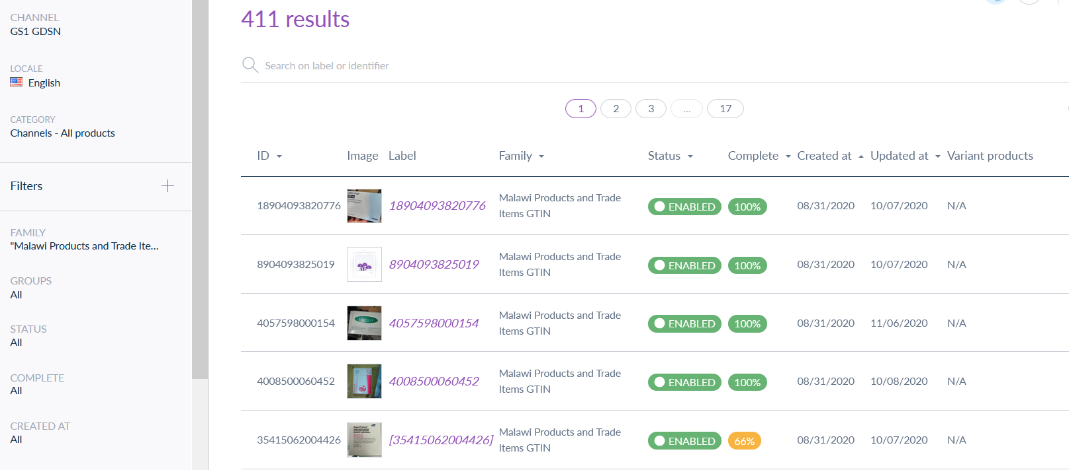
The product attribute page will display with all the available attributes for the product/item.
Figure 13: Product Attribute Page
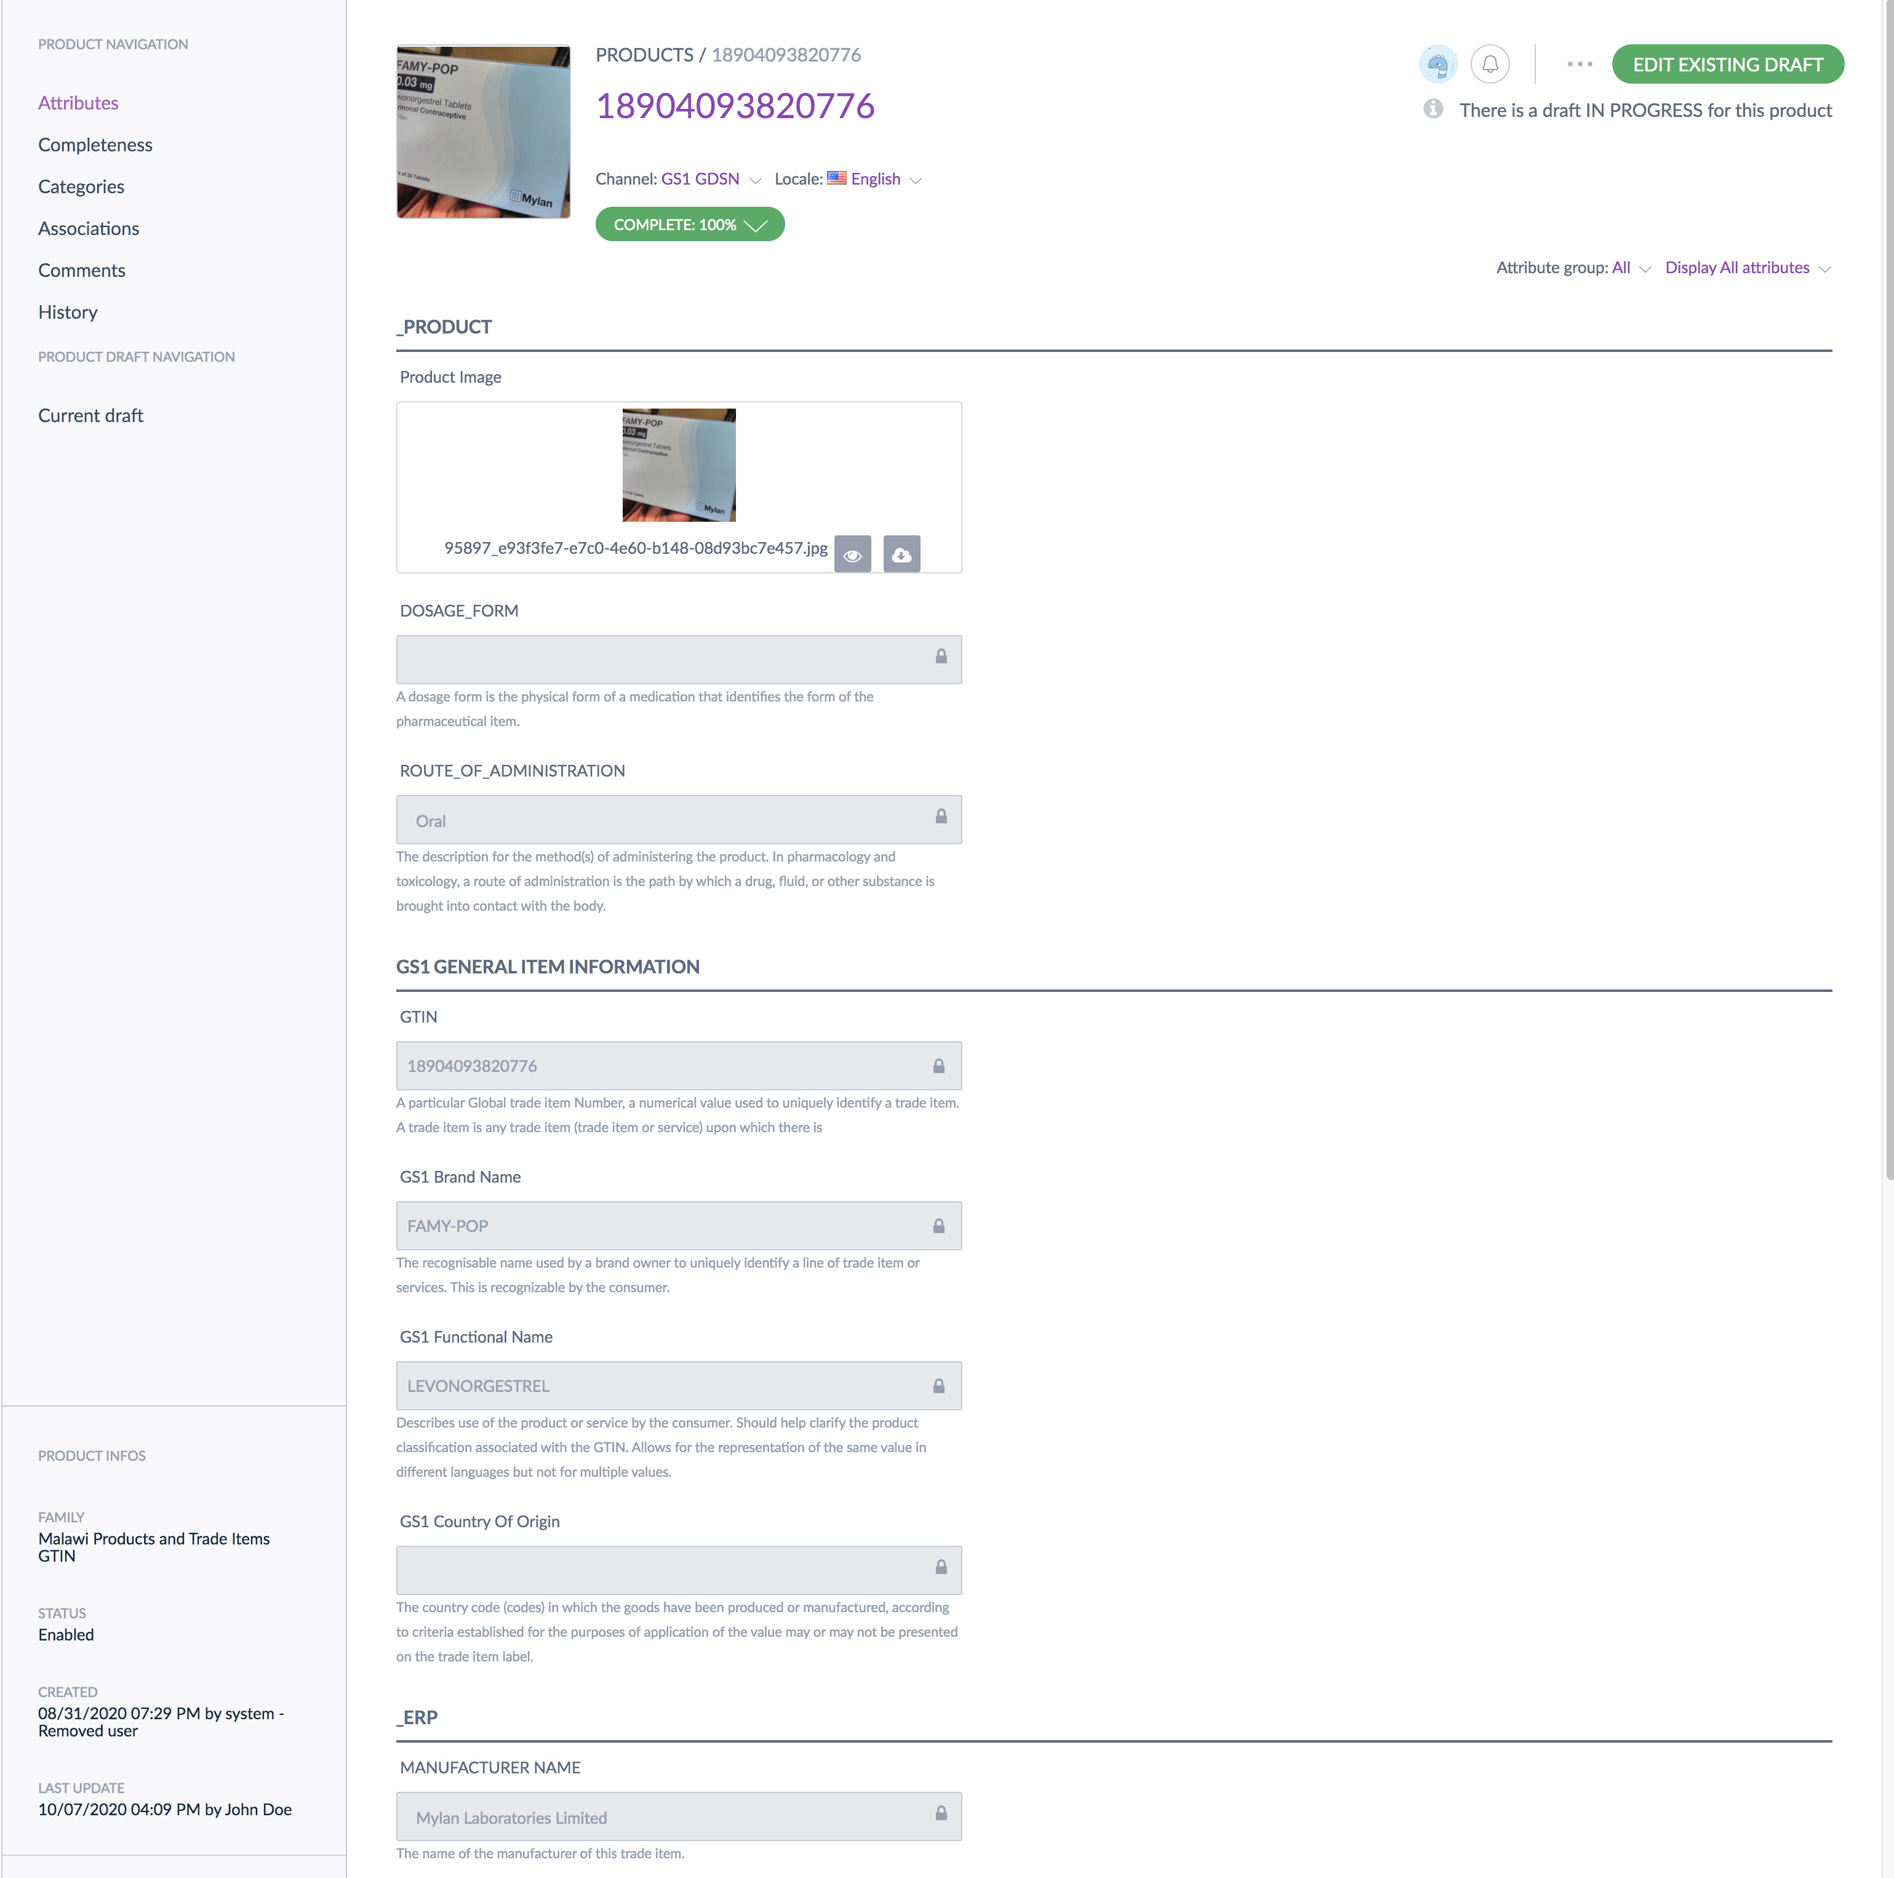

Adding a New Product
This section provides an overview of the process and steps to add a new product/item to the NPC.

Process Overview

Figure 14: Add New Product/Item Process Flow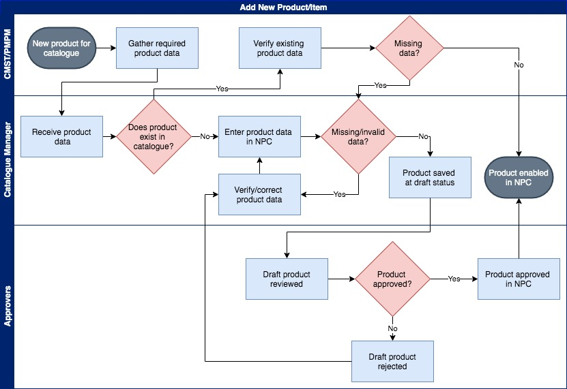
1
2
3
4
5
6
7
8
When a new product/item needs to be added to the NPC, the following steps must occur:
- All required data (see sections 3.4 and 4.3 for more information on creating products and product attributes) must be collected and provided for the product/item, including all the necessary attribute data (manufacturer, product brand and function details etc.)
- Upon receiving the product/item data, the Catalogue Manager verifies that all the required data was provided and is valid (correct format, length, etc.)
- The Catalogue Manager verifies that the product does not already exist in the NPC to avoid duplication.
- Product/item data is added to NPC either through an upload using a formatted spreadsheet or manual entry in the UI.
- The system will not accept the product if required attributes are missing or invalid. If there are issues, the Catalogue Manager must verify again that all required data is included and valid.
- Once all required data is uploaded or entered, the product is saved as a draft in the NPC.
- The draft product and its attributes will be reviewed by the approvers. If rejected, the Catalogue Manager must verify the data and correct any issues that caused the rejection.
- Upon approval, the new product is enabled in the NPC and available for users and other systems.

Adding Items to the NPC
Follow the steps in this section to add a trade-item to NPC through the user interface. In the NPC system, adding or modifying
Figure 15: Create Product from Product Grid
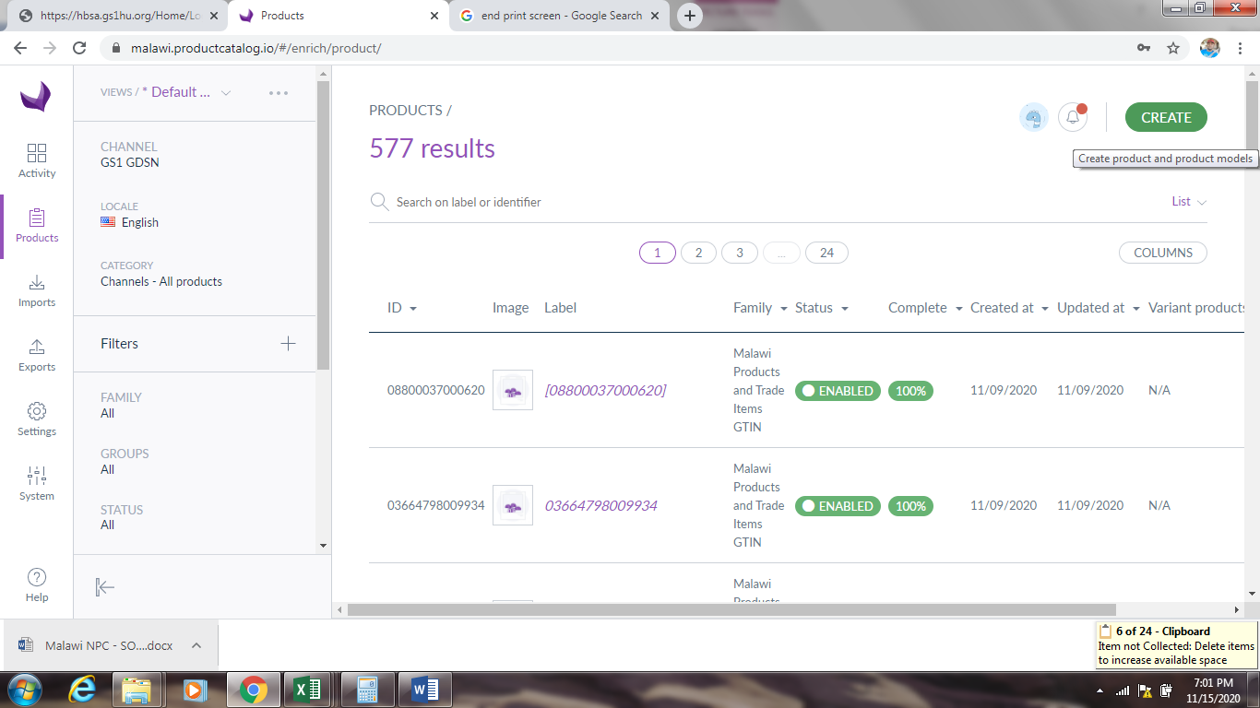
3
1
2

Figure 16: Create Product Options
- Click on PRODUCTS
4
- SEARCH to verify that the ID (GTIN) does not exist (if not, move to step 3).
  - If the ID (GTIN) does exist in the system, verify that the request matches the existing item data. If not, verify with the requester if the existing product should be modified or if the data in the request was incorrect.
- Click on CREATE
- Click on PRODUCT

Figure 17: Create Product
5
6
7
- Enter UNIQUE ID (GTIN)
- Select the appropriate FAMILY (new trade-items will belong to the <Country> Trade Items family)
- Click SAVE
  - Once saved, the new item must be approved (see section 3.4.3). Once approved, additional item data can be added to the record by following the steps to edit a product/item (section 3.7)

Approving New Products
Once added and saved as drafts, new products must be approved in order to be enabled and active on the NPC.
Figure 18: New Product Drafts
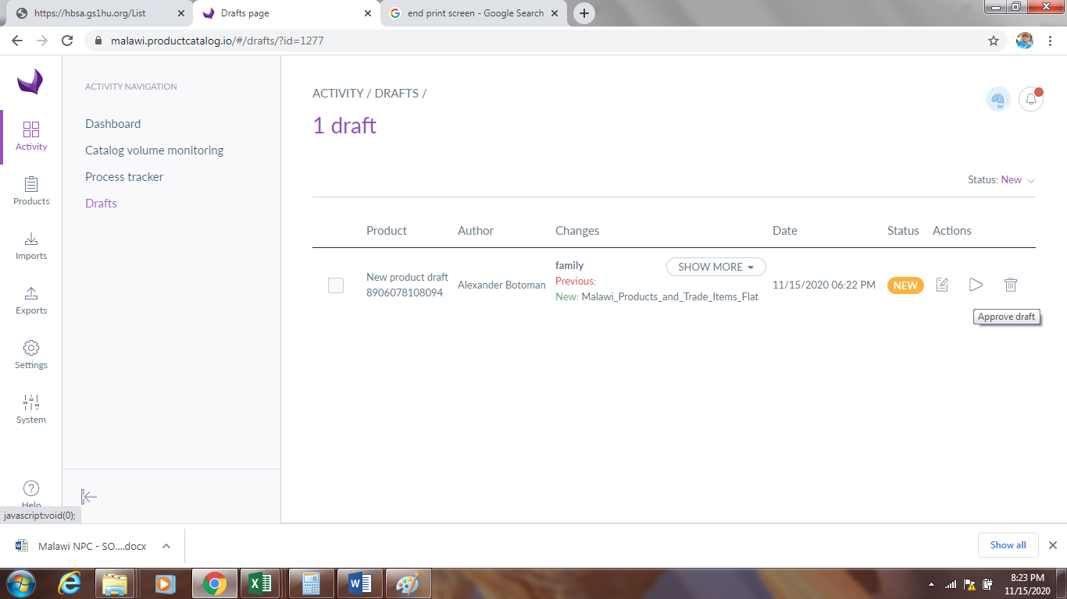
3
1
2
- Click on Activity
- Click on Drafts
- Click on approve draft icon (you can also click the EDIT icon to make changes to the draft or the REJECT icon to reject the draft)

Figure 19: Draft Approval
4

- Click APPROVE to confirm approval and enable the new product/item.

Adding Product Models
A product model is used to manage products with variants (same product but with different manufactures), it gathers variant products and eases the enrichment of their common properties. Products with variants are products that have similarities; they are based on the same model, but differ in some aspects from one another. In the <Country> NPC system, the generic MHPL product codes are considered product models and the trade-items with GTINs that are mapped to those generic products are the variants.
Entry of product model data should precede adding of items in order to have products (trade-items) mapped to product models (MHPL codes).

Creating Product Model
Follow the steps in this section to create a product model.
Figure 20: Create Product Model
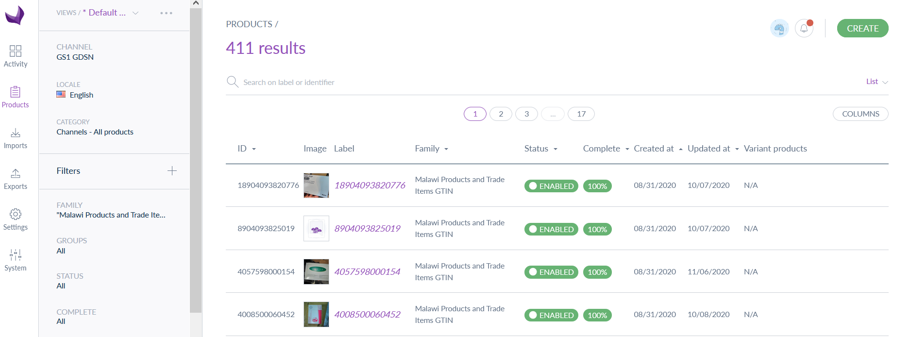
1
2
- Click on PRODUCTS
- Click CREATE

Figure 21: Create Product Options (Product Model)
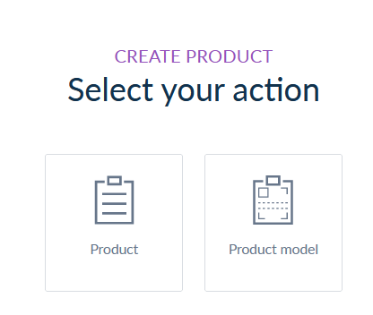
3

- Click on PRODUCT MODEL

Figure 22: Create Product Model – Definition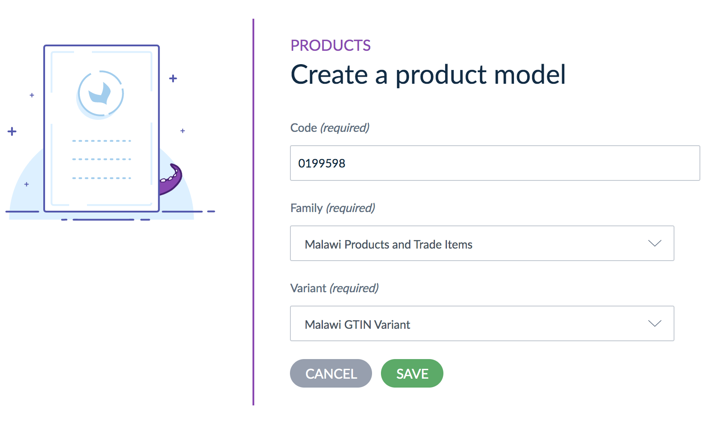
4
7
6
5
- Add the CODE (MHPL code) to identify the product model
- Choose a FAMILY (for <Country> MHPL products the family will be <Country> Products and Trade Items)
- Choose a VARIANT (for the <Country> NPC, use the <Country> GTIN variant). A family variant defines the way variant products in this model are structured (see 3.6 for additional details)
- Click SAVE
  - Once saved, the new product model must be approved (see section 3.5.2). Once approved, additional product model data can be added to the record by following the steps to edit a product/item (section 3.7)

Approving a Product Model
Once a product is created, it must be approved in order for it to be visible and accessed by others. Follow the steps in this section to approve a product model.
Figure 23: Drafts - Product Model
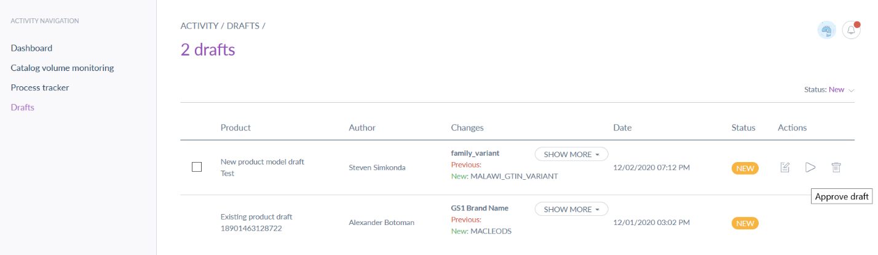
2
1

Figure 24: Approve Product Model
- From the Activities section, click on DRAFTS
3
- Click on APPROVE draft icon for the new product model (you can also click EDIT or REJECT to make changes or reject the draft)
- Click APPROVE to confirm approval and enable the new product/item
Once approved, the new product model will be enabled and available for use.

Creating Associations (Mapping)
To create linkages between generic products (MHPL) and the unique trade-items (GTINs/item-specific identifiers), an association must be defined between the item and the generic product that it falls under. Creating such associations defines the item as a variant of the generic product.

Adding Associations
Follow the steps in this section to add associations (map) items to products.
Figure 25: Product Grid View
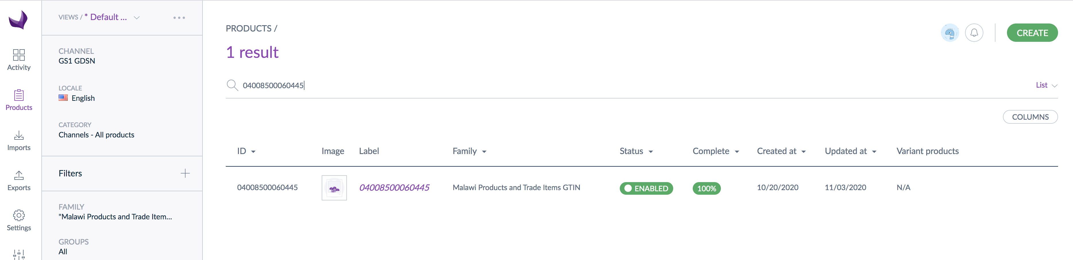
1
3
2
- Click on PRODUCTS
- Find the item on the product grid or use the search bar to look up the item ID
- Select the item to see the item details
  - Ensure GTIN and Manufacturer are populated
Figure 26: Product Detail View
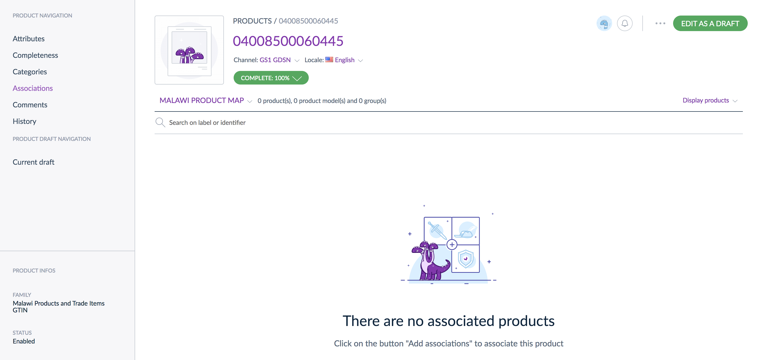
4
- Click the Edit as a Draft button
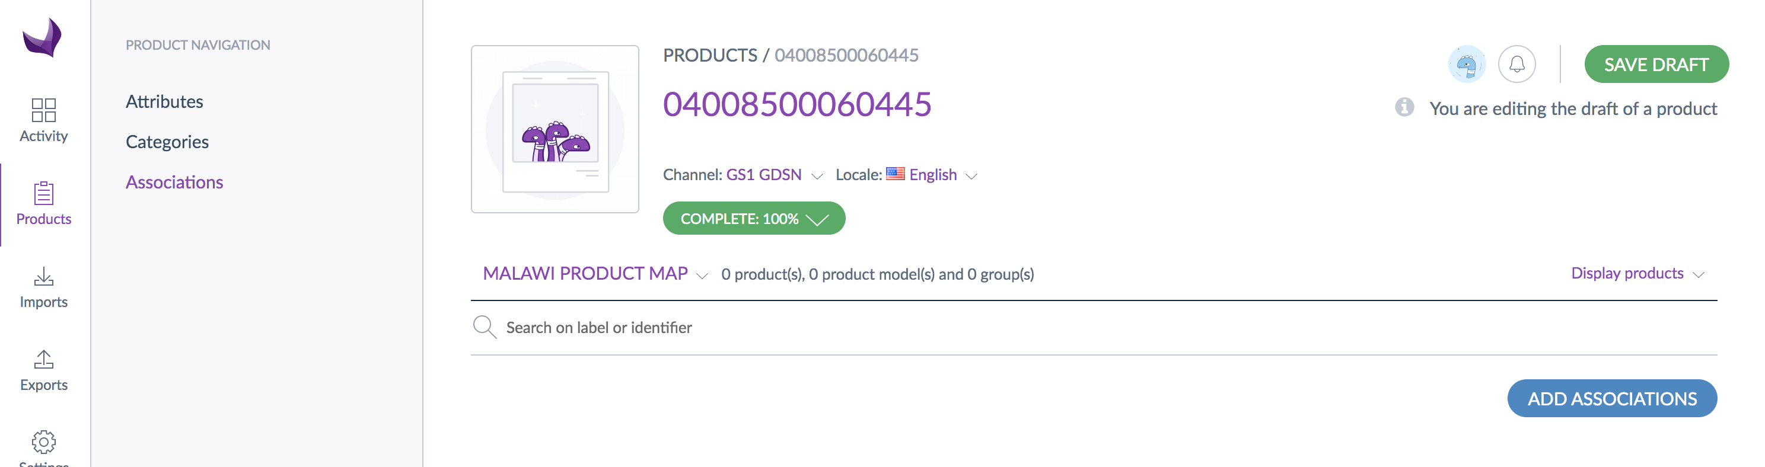
5
6
7
- Click on Associations for the item
- Select the Association Type of <Country> Product Map
- Click Add Associations
Figure 27: Add Associations Screen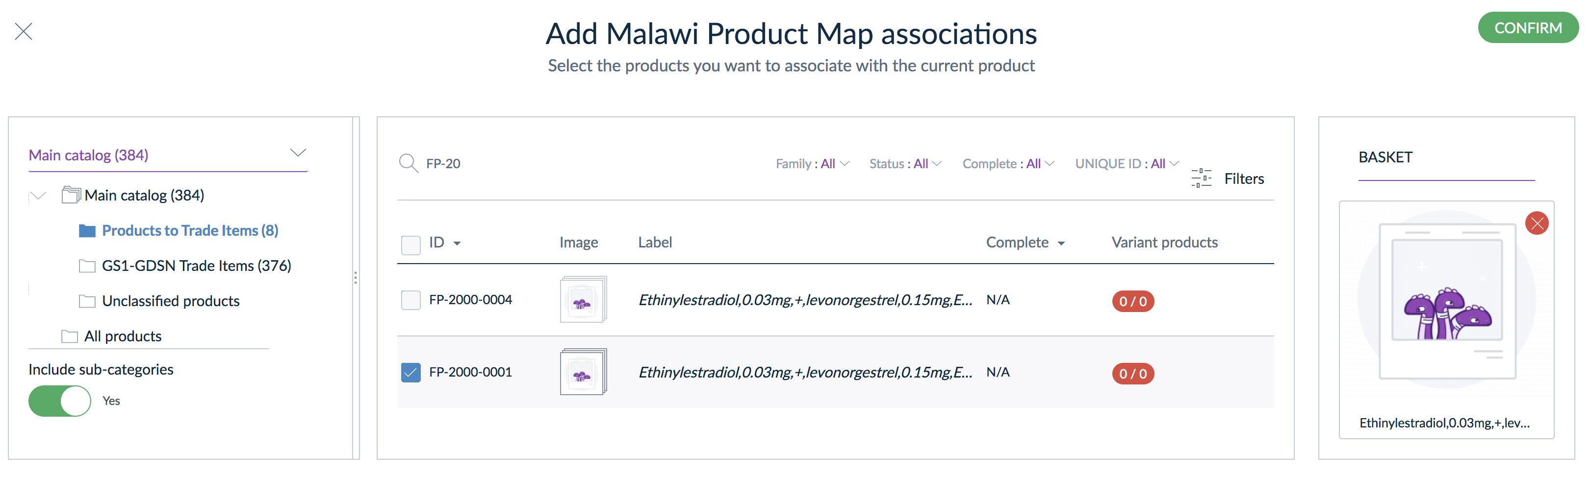
8
10
9
11
- Select Products to Trade Items under Main Catalog
- Use the search box or page through the products to find the <Country> product to which you will associate the item
- Click the checkbox next to the appropriate <Country> product
- Click the Confirm button when ready, you'll see the <Country> product mapped
Figure 28: Product Associations Page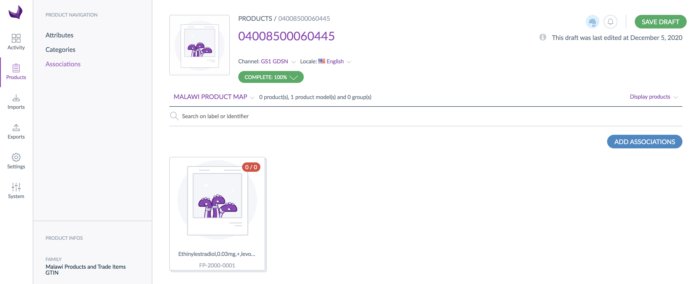
12
- Click the Save Draft button to save the draft changes for review

Approving Associations
As with adding new products/items and product models, draft associations much be approved to be enabled in NPC. Follow the steps in this section to approve associations.
Figure 29: Approve Draft Associations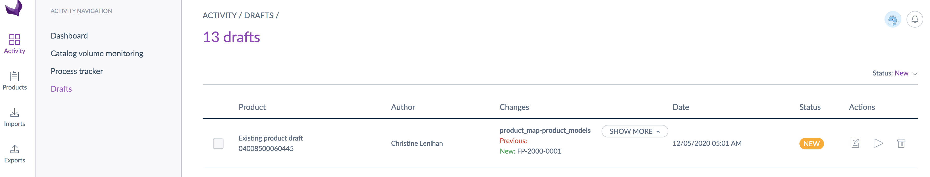
1
2

Figure 30: Approve Association
- From the Activities section, click on DRAFTS
3
- Click on APPROVE draft icon for the new association (you can also click EDIT or REJECT to make changes or reject the draft)
- Click APPROVE to confirm approval
Once approved, the new association will be enabled and the item will be available in NPC as a variant of the generic product to which it was associated.

Editing Products/Items
If there is new or updated information for an existing product/item, it can be edited to ensure the NPC is accurate and up-to-date. Follow the steps in this section to edit a product.

Editing a Product/Item

Figure 31: Product Grid - Editing Existing Products
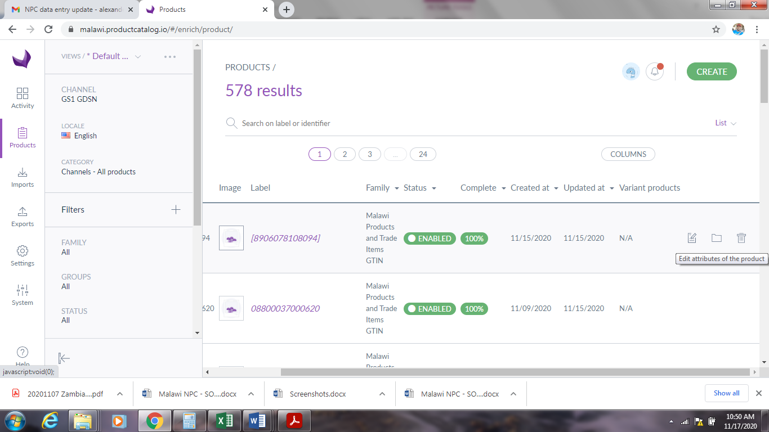
1
2
3

- Click on Products
- Use the search bar to search for the product/item ID to be edited
- Click on edit icon
Figure 32: Product Detail View - Edit
4
- Click edit as a draft
Figure 33: Edit Product/Item Attributes Screen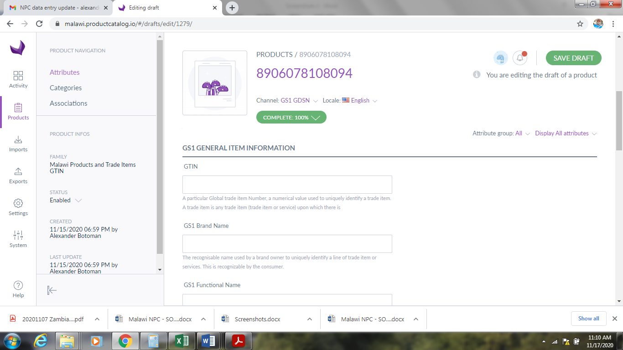
6
5
- Add or update existing attributes as required (see section 4.3 for a list of attributes for products and items).
- Click save draft after all necessary fields are filled

Adding Categories to a Product
A category is used to classify products and items. A category can have multiple sub-categories and levels, which forms a category (or classification) trees. A product or item can be in several (or no) categories. In <Country> , categories include dosage forms, supplies, and programs. Categories can also be used to add GS1 global product classification (GPC) systems to the product catalogue. Follow the steps in this section to assign a product to a category.
Figure 34: Edit Product - Categories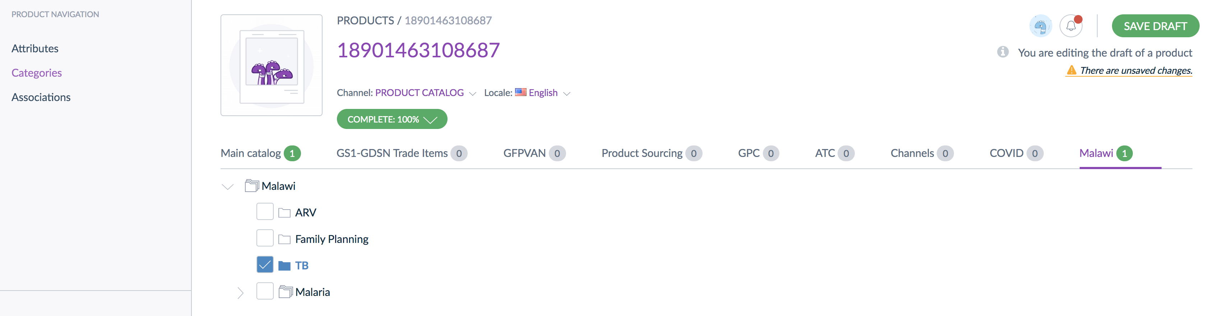
1
2
3
4
- From the edit product screen (follow steps 1-4 of section 3.7.1) click CATEGORIES
- Select the CATEGORY TREE you want to use (such as <Country> )
- Click the CHECKBOX next to the category(ies)/sub-category(ies) the product should be assigned to (a product can be assigned to multiple categories)
- Click SAVE DRAFT

Adding Hierarchical GTINs to an Item
Hierarchical GTINs are a product attribute that identifies packaging structure of an item. These can include pallet-level, case, pack, or inner pack GTINS. To add Hierarchical GTINs, follow steps 1-4 of section 3.7.1 to get to the edit item screen. From that point, follow the steps in this section.
Figure 35: GTIN Hierarchy Attributes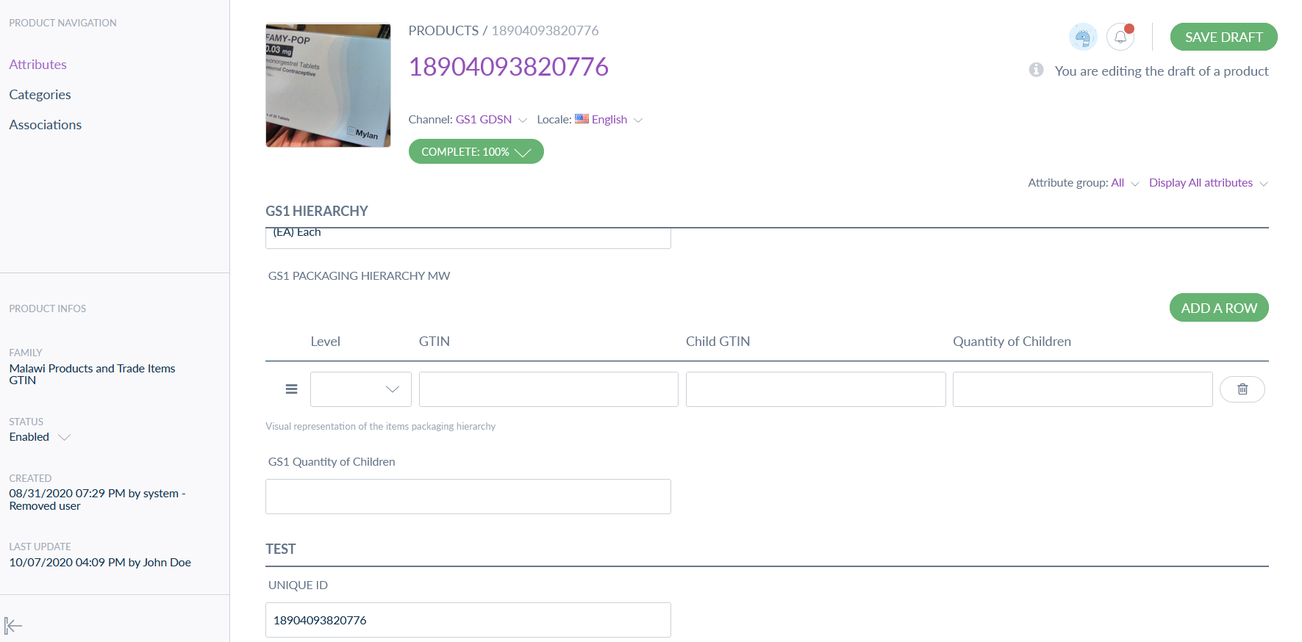
1
3
4
2
- Go to the GS1 HIERARCHY section in Attributes
- Click on ADD A ROW to generate a row for data entry.
- Add the Hierarchical GTIN information
  - If there are several GTINs repeat step 2 and 3 until all are added
- Click SAVE DRAFT

Approving Edited Products/Items
As with adding new information (products/items, product models, associations etc.), any information that it updated or added after the product/item exists must be approved. Follow the steps in this section to approve edited products/items.
Figure 36: Edited Product Drafts
4
3
1
2
- Click on activity
- Click on drafts
- Changes made to a product attributes will be seen here
- Click the approve draft icon
Figure 37: Approve Edited Product
5
- Click APPROVE
Once approved, the new or updated information will be included in the product/item data available for other users and systems.

Deleting or Deactivating Products/Items
If a product is no longer available and/or has been phased out, or entered incorrectly you may need to remove it from the NPC to ensure it remains accurate and up to date. Products/items can be removed from the NPC in 2 ways: through deletion or deactivation (see section 2.3). Deactivation, rather than deletion, is recommended to maintain historical information and allow for re-activation if required.

Process Overview
Figure 38: Delete/Deactivate Product/Item Process Flow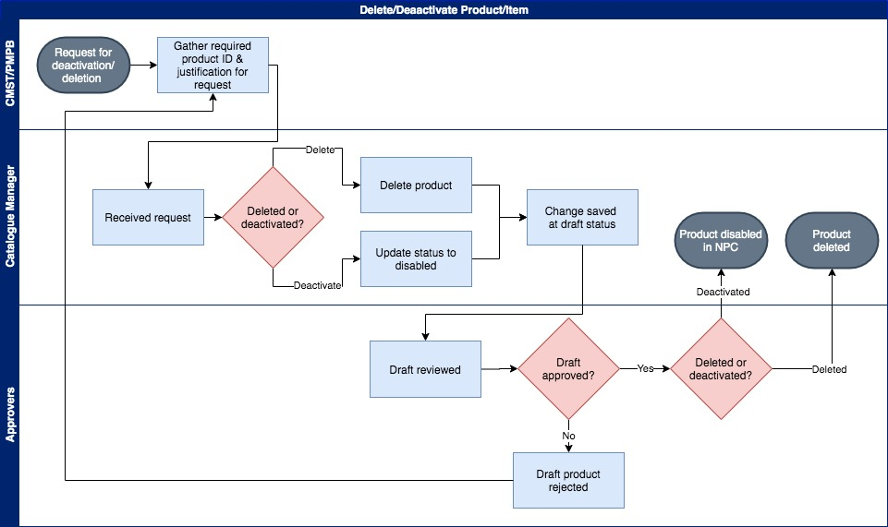
1
2
3
4
5

- An official request and justification for product deletion/deactivation received by the catalogue manager
- When deleting or deactivating a product or item the user will look up the product using a key attribute (the unique product ID) in the product section search field. To deactivate a product/item the product/item status is updated to disabled in the product details screen (in edit mode). Once the changes are saved, the product disabled status is saved as a draft until approved.
- To delete a product, click on the trash bin icon in the product grid on the right side of the product ID. This will give an option to delete the product/item (or cancel).
- After a product or item has been deleted or deactivated the changes will be saved as a draft until they are reviewed and approved.
- After approval the deletion/deactivation will take affect and the product/item will not be available or active in the NPC.

Deleting a Product/Item
Follow the steps in this section to delete a product/item.
Figure 39: Delete Product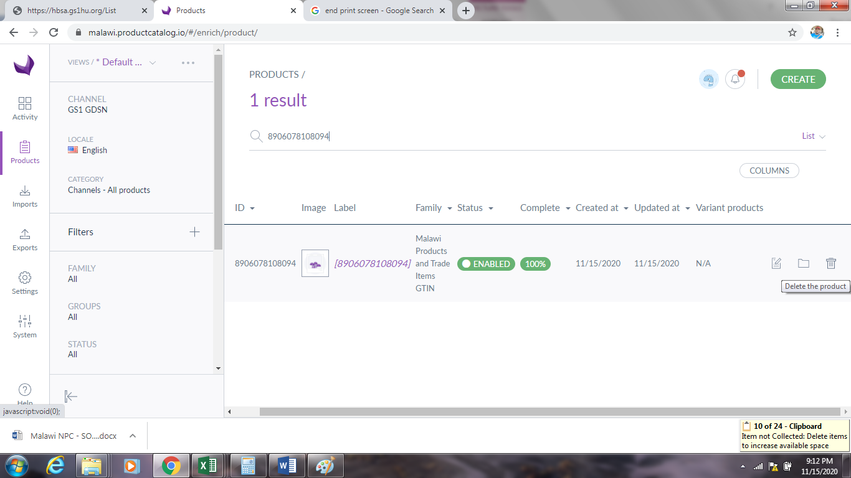
3
1
2
Figure 40: Confirm Product Deletion
- Click on Products
4
- Use the search bar to search for a specific product ID/product Model ID
- Click on the Delete icon
- Click Delete to confirm deletion

Deactivating a Product/Item
Follow the steps in this section to deactivate a product/item.
Figure 41: Deactivate Product/Item
3
1
2
- Click on Products
- Use the search bar to search for a specific product ID/product Model ID
- Click on the product/item to open the Product Details page.
Figure 42: Product Details - Deactivate
4
Figure 43: Deactivate Product/Item
5

- Click EDIT AS A DRAFT
- Select DISABLED as the status in the left sidebar
- Click SAVE DRAFT

Figure 44: Save Draft - Deactivation
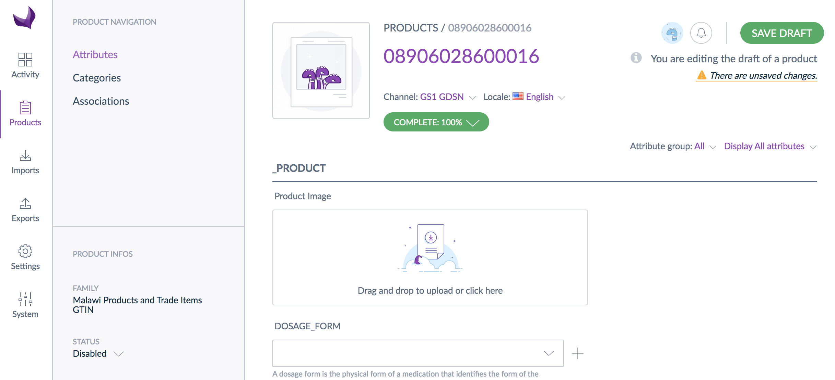
6
Both deletions and deactivations are saved as drafts until approved. The approval process is the same for deletion/deactivation as other edits (see section 3.7.2).

Data Import & Export
Imports and exports can be used to import (upload) or export (download) configuration or product data from NPC. This section provides an overview of running imports and exports using existing profiles (see section 3.9.3 for a list of the key existing profiles). Section 4.5 provides details on creating and managing import/export profiles.

Import Data
Follow the steps in this section to import product or configuration data.
Figure 45: Import Profiles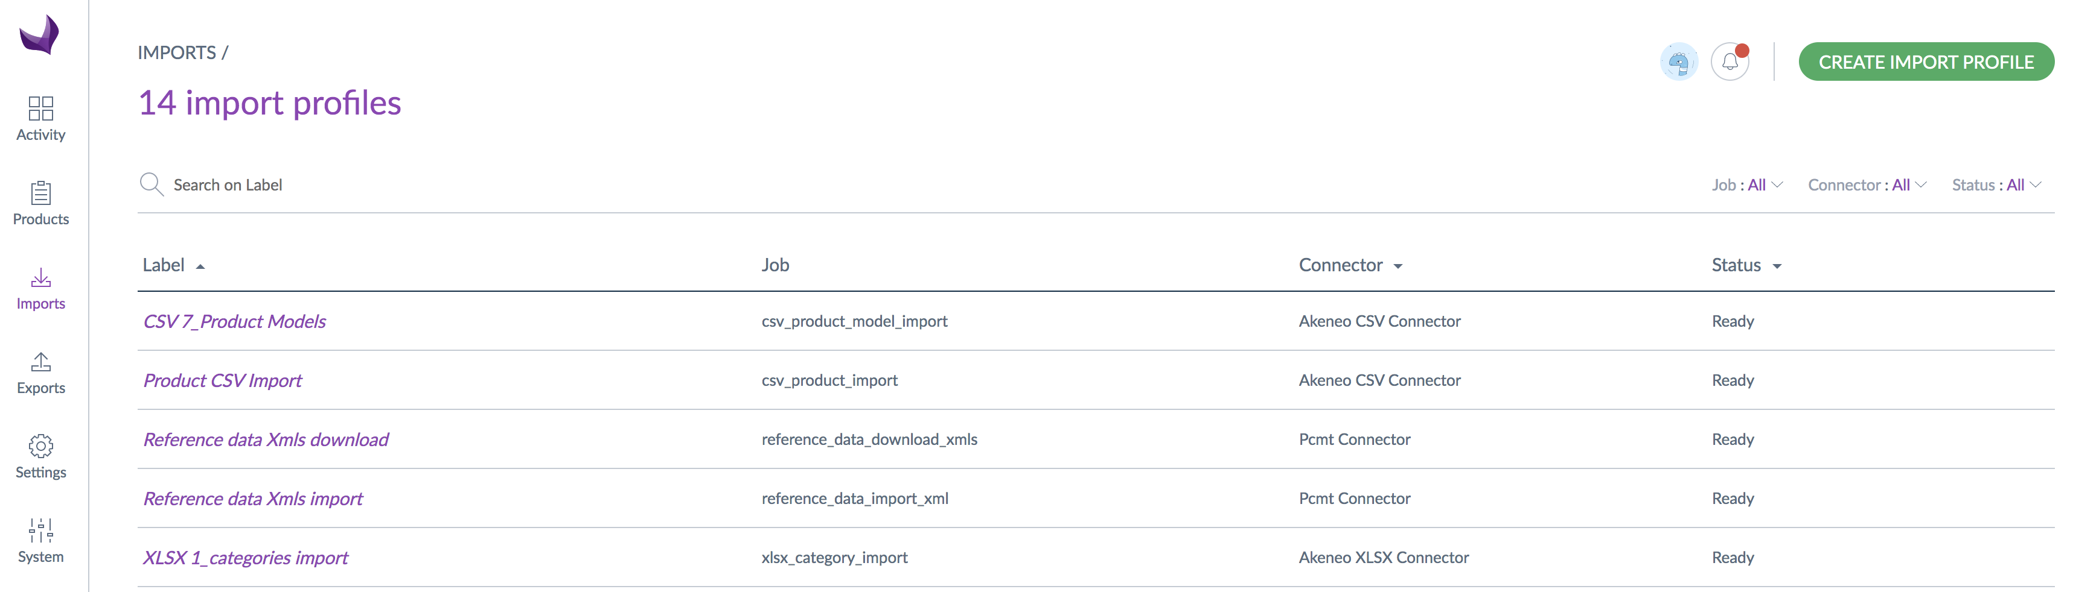
1
2
- Click IMPORTS
- Click on the appropriate IMPORT PROFILE for the data you want to import
  - NOTE: Import profiles are either Excel (XLSX) format or CSV format. Data from XLSX files will be imported as draft data which will need to go through the approval process. CVS files bypass the draft stage.
Figure 46: Upload & Import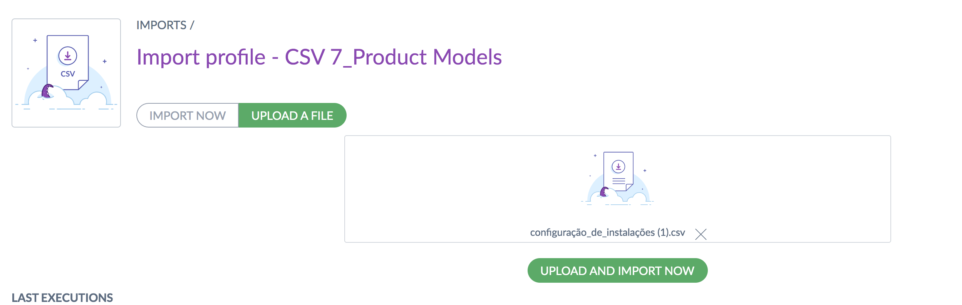
3
4
5
- Click on UPLOAD A FILE*
- Select the file to upload
- Click UPLOAD AND IMPORT NOW
*If you do not know the required format for a data file you want to import, create an export of the relevant data using an existing XLSX or CSV export profile (or create a new one) and use the exported file as a template.
Import status can be viewed in the process tracker (section 3.2.3).

Export Data
Follow the steps in this section to export product or configuration data.
Figure 47: Export Profiles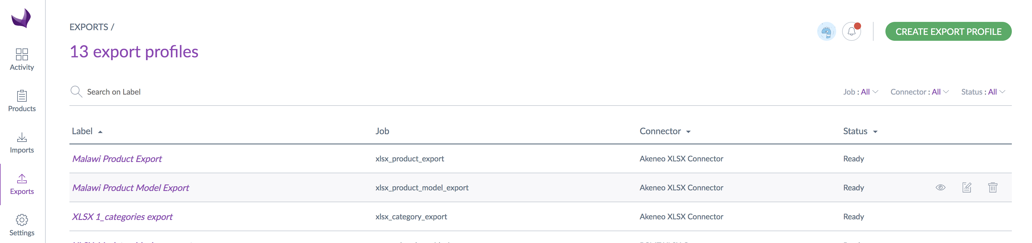
1
2
- Click EXPORTS
- Click on the appropriate EXPORT PROFILE for the data you want to export
Figure 48: Export
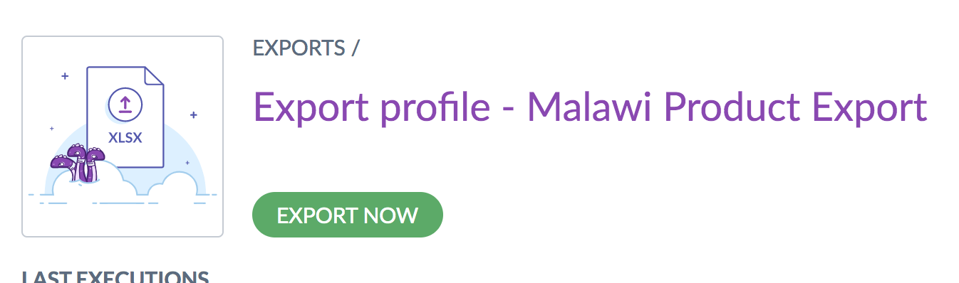
3
- Click EXPORT NOW
Figure 49: Download Export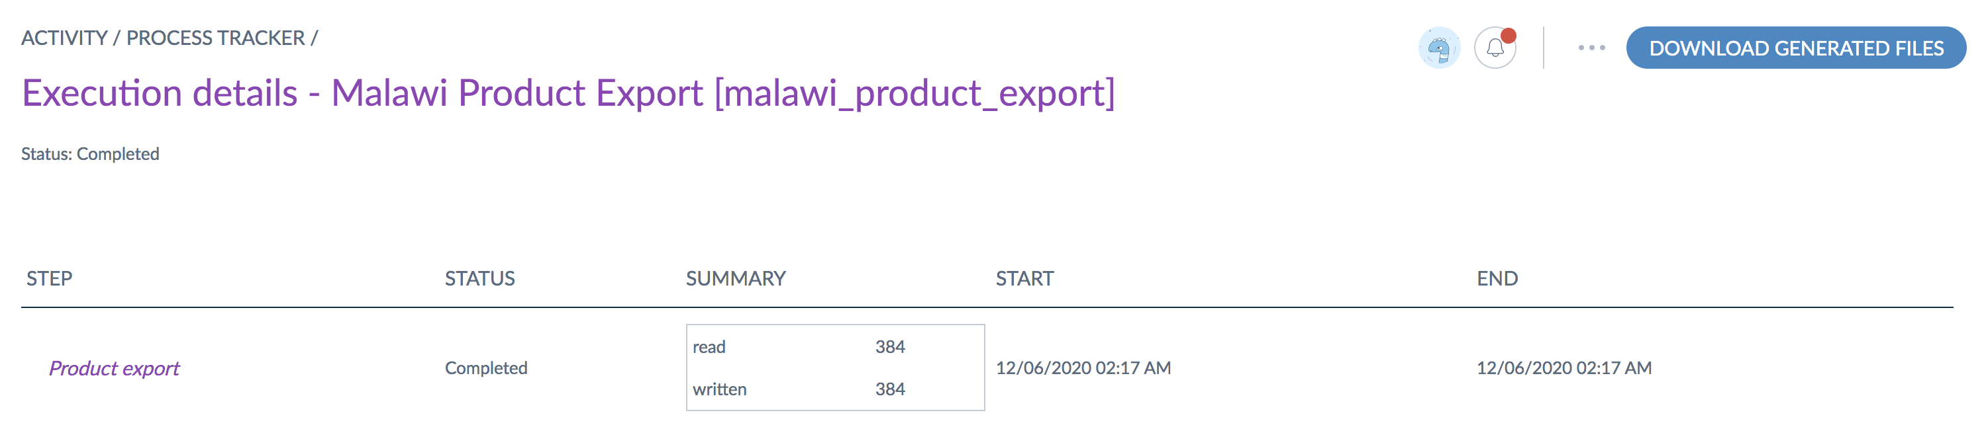
4
- Click DOWNLOAD GENERATED FILES to download and save the export files

Key Import/Export Profiles
The table provides an overview of key import/export profiles for the <Country> NPC.

Table 2: Key Import & Export Profiles
Profile Name | Function | Description
CSV 7_Product Models | Import | Imports (uploads) product model (MHPL) data in CSV file format. The CSV format does not go through the approval process.
XLSX 7_Product_models import | Import | Imports (uploads) product model (MHPL) data in XLSX file format. The XLSX format does go through the approval process.
Product CSV Import | Import | Imports (uploads) trade-item (GTIN) data in CSV file format. The CSV format does not go through the approval process.
XLSX 8_Products import | Import | Imports (uploads) trade-item (GTIN) data in XLSX file format. The XLSX format does go through the approval process.
XLSX 1_categories import | Import | Imports (uploads) category data in XLSX file format. The XLSX format does go through the approval process.
<Country> Product Export | Export | Exports (downloads) trade-item (GTIN) data in XLSX file format.
<Country> Product Model Export | Export | Exports (downloads) product model (MHPL) data in XLSX file format.
XLSX 1_categories export | Export | Exports (downloads) category data in XLSX file format.

System Administration & Configuration

Creating and maintaining the NPC is not a one-off task, but an ongoing initiative that will require continuous maintenance, monitoring, updating, and review to ensure the catalogue is kept complete and up-to-date. This section provides information related to key configuration and administration tasks for ongoing NPC maintenance such as user management and creating or modifying product configuration elements (attributes, categories etc.).

Roles and Responsibilities
Ongoing maintenance and management of the NPC requires the Ministry of Health through the Directorate of Pharmaceuticals to lead the process in collaboration of Directorate of Quality Assurance and Digital Health and Central Medical Stores. The management of the PCMT requires the establishment of the position of the Catalogue Manager. A Systems Administrator will also be required. However, this role can be handled by one of MoH technical department such as ICT department or Digital health department.
Key NPC processes include data collection, cleaning, uploading/creation, review and approval, updates (modification and deletion/deactivation) and mapping product identifiers across systems at country level. These roles are assigned to two key personnel; the catalogue manager and systems administrator in the government institution responsible for the NPC management.
Table 3: Roles & Responsibilities
Roles | Key Responsibilities
Data Collection | Collecting product data from manufacturers, donors and directly from products in warehouse
Data Cleaning | Ensuring the data extract file conforms to PCMT attributes  Ensure collection of standard GTIN characters
Data uploading | Uploading product data into PCMT  Resolving upload challenges
Review and approvals | Approving product modifications in PCMT
Updates or modifications | Updating product data in PCMT  Removing or modifying product data in PCMT as needed
Product mapping | Mapping GTINS to local codes for consistent product identification across health care systems and tiers

National Product Catalogue Manager
This role is responsible for managing product/item master data and support the strategic development of the National Product Catalog (NPC). The National Product Catalogue Manager or Catalogue Manager will be based in the department of pharmaceuticals working closely with the Directorate of Quality Assurance and Digital Health. The key roles include the following:
- Establish product master data governance (SOPs) for all health commodities
- Populate and maintain product/item master data in NPC for all assigned health commodities
- Facilitate on-going management of product/item master data in NPC
- Support data exchange across all applicable supply chain levels in the country
- Develop and implement GDSN synchronization strategy
- Conduct data quality assessments and adjustments
- Adding & updating product data
- Reviewing & approving product changes

System Administrator
The System administrator is responsible for overall technical management of systems support. This includes (but is not limited to):
- User account creation, management, and support
- Data imports/exports, linkage with other systems support
- Routine system monitoring and maintenance
- System updates
- Hosting & other system support
Additionally, the Directorate of Quality Assurance and Digital Health in collaboration with the Department of e-government and MoH ICT department will provide system oversight and governance. This oversight is important to ensure that the technology is well managed, sustainable, and aligned with the e-health strategy agenda.

User Management
To access the NPC, one must have a user account. The NPC has role-based access controls, which allows administrators to create roles – a set of parameters and permissions – that can be assigned to user accounts to determine what functions a given user can perform. Roles can be set up based on specific functional permissions (i.e., a data entry role that includes only permissions for data entry with separate roles for data export or configuration). Users can also be put into groups for more efficient user management.
User accounts, roles, and groups are related and can be used in various configurations and combinations to control user access to the system, as illustrated in Figure 49.
Figure 50: User Accounts, Roles, & Groups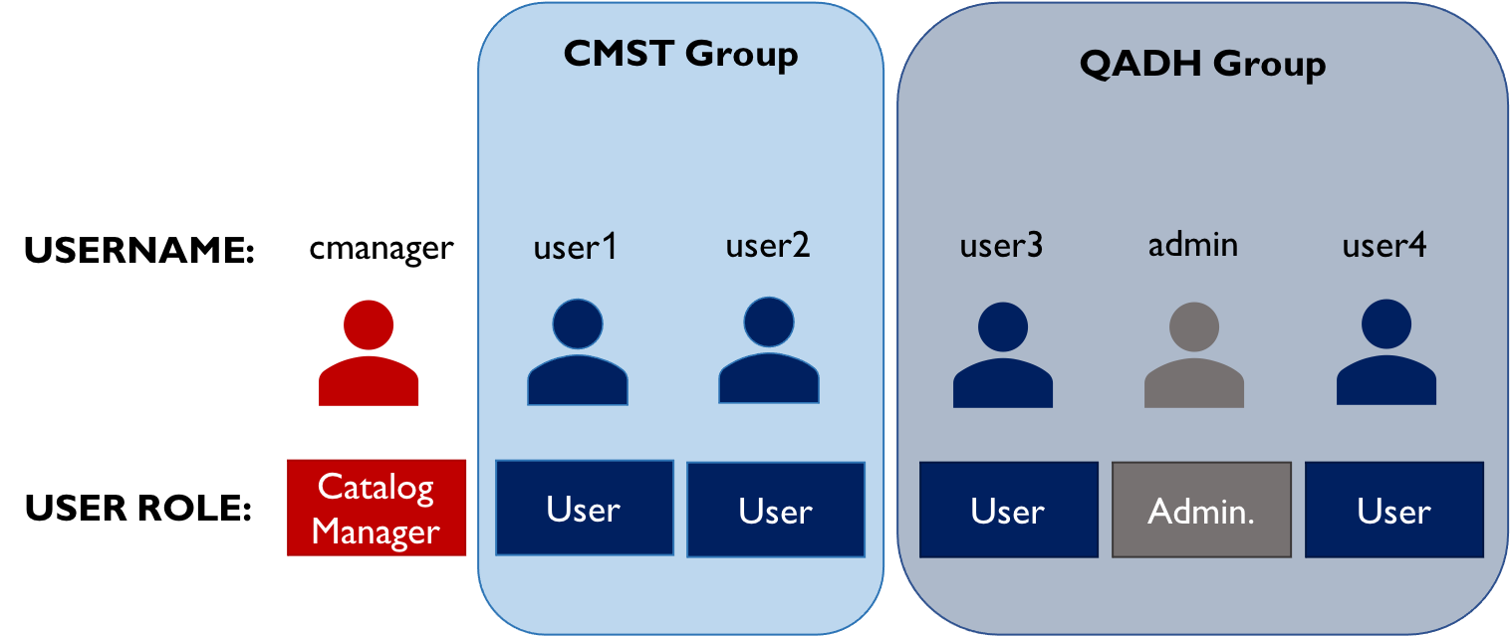
In order to log in to the NPC system, a user must have a user account (username). A user account must be assigned at least one user role to grant them permissions to view data and/or perform any functions in the system. Users can be assigned more than one role if needed (depending on how roles are configured). Users can also be assigned to groups (for example, based on their organization or department) to allow for easier user management. Users in a group do not have to have the same roles. Users can be assigned to multiple groups, but they do not have to be in any groups.
Table 4 lists the user roles that are currently set up in the <Country> NPC.
Table 4: User Roles
User Roles | Description
Administrator | The administrator role includes full access/permissions for users assigned this role to perform all system functions.
API user role | The API user role includes permissions for a user account to access, create, and update data via the system APIs. These functions would be used for system integration with mobile applications, other HIS, or other product catalogues/data sources for automatic data updates.
Catalog manager | The Catalog Manager role has full access to enter, edit, and manage NPC product data and configuration
User | Intended for general users, the basic user role includes permissions to enter and update data as well as export data. The user role does not include permissions to update configuration or delete products.
This section provides information for key user management functions. More information on user management is available on the Help Site.

Creating User Roles
The roles assigned to users to control access and functions in the system can be created and updated if new or different roles are required to assign different sets of permissions. If, for example, there was a need to provide user accounts to individuals who needed to see the data in the NPC, but could not make any changes or additions, a new role would be needed with more restrictive permissions. Follow the steps in this section to create a new role (note that a user must have role management permissions to complete these actions).
Figure 53: User Role Management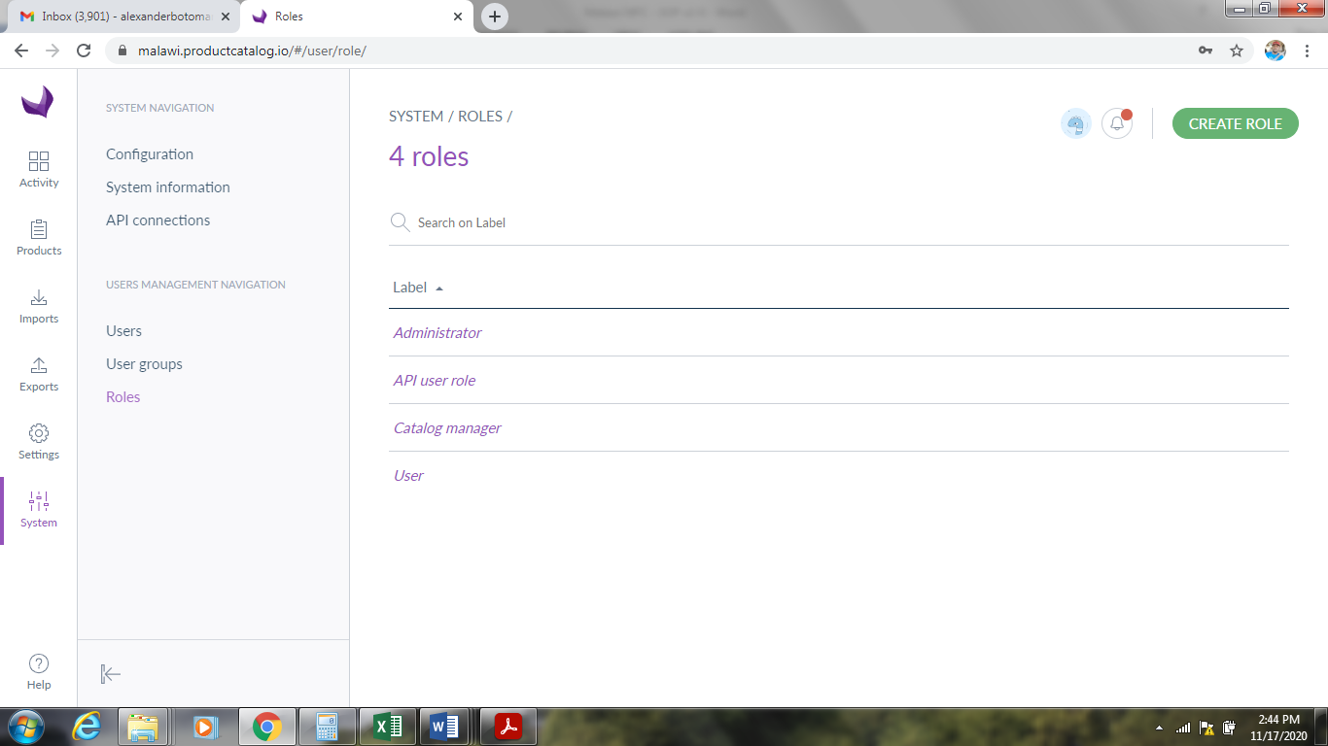
1
2
3
- Go to System
- Click on the Roles menu entry
- Click on the Create Role button
Figure 54: Create Roles
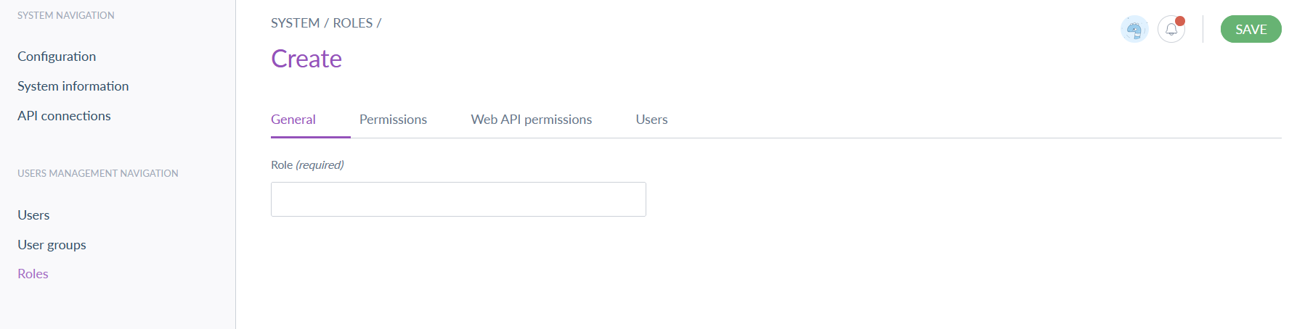
4
5
- On the General tab, enter a ROLE NAME
- Click Save

Assigning Permissions to User Roles
Once a role is created (or during its creation), it must be assigned permissions to determine what users with that particular role have access to in the NPC. Follow the steps in this section to assign permissions to roles either when creating a new role (from step 4 in section 4.2.1) or after the new role has been created by clicking on the role from the Role Management screen (under Label in Figure 55).

Figure 55: Assign Role Permissions
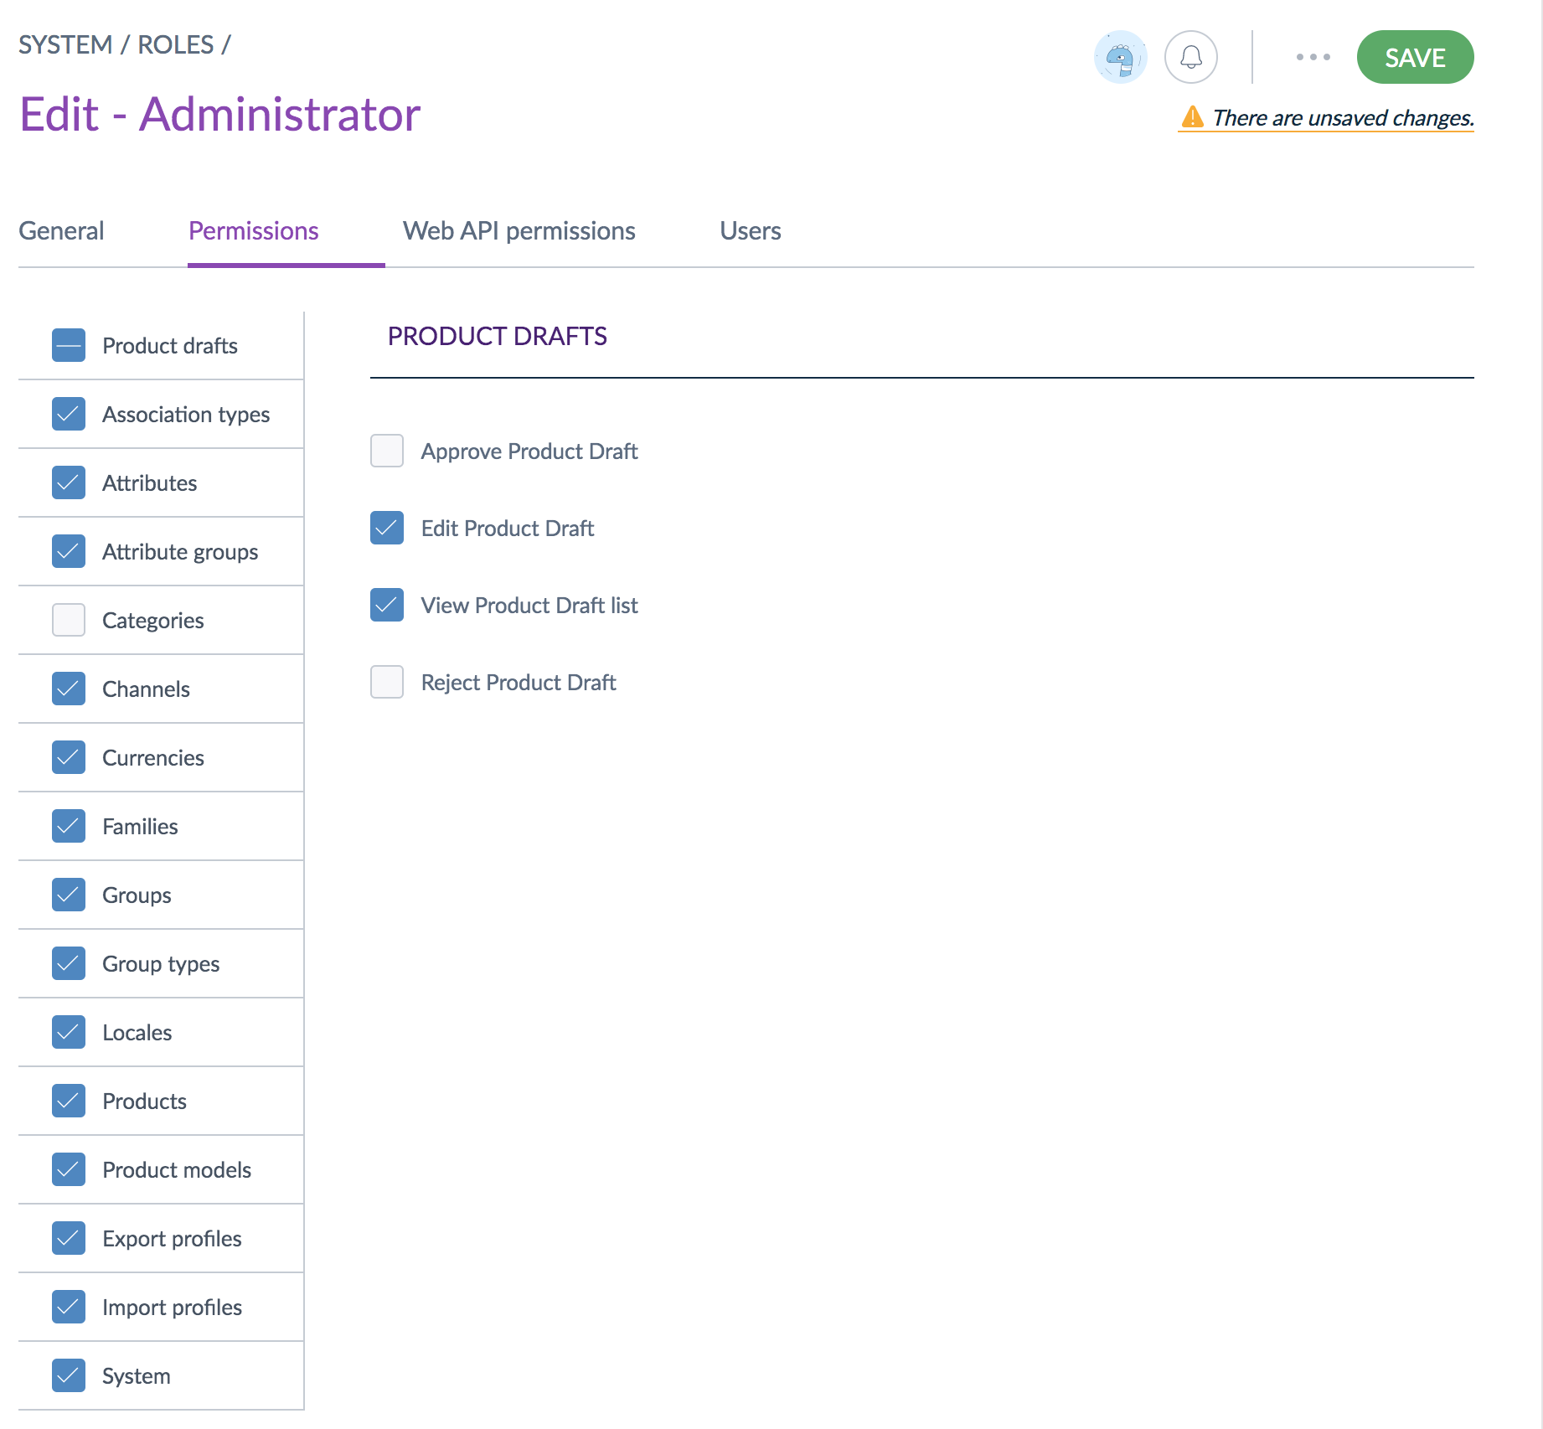
5
2
4
1
3

- Click on PERMISSIONS

- A list of permission categories with checkboxes appear on the left, with specific rights in that category on the right

- Click on a Permission Name to see the rights under that category

- Click on the CHECKBOXES to select or deselect permissions
  - Blue boxes with a checkmark indicate that this permission is assigned to the role
  - White, empty checkboxes indicate that the permission is not assigned to the role
  - Blue boxes with a dash on the permission category indicate that some of the rights, but not all, in that category are assigned to the role.
  - Selecting or deselecting the permission category will select/deselect all the rights that fall under that category
- When all permissions are assigned, click SAVE
The different permissions assigned to the role will be applied to the user when a user is assigned the role. Table 5 provides a list of key permissions and description of each.
Table 5: User Permissions
Permission | Description
Add product to groups | User can add products to group, in Settings/Groups they will see the Products tab
View the associations of a product | User can see the Associations menu entry in the product form
Add associations to a product | User can add associations in the Associations tab using the Add Associations button
Remove associations to a product | User can remove an association in the Associations tab using the cross
Consult the categories of a product | User can see the Categories menu entry in the product form
Change product family | User can change the product’s family in the panel on the left of the product form
Change state of product | User can change the status of the product: enable or disable directly in the panel on the left of the product form
Comment products | User can see the Comments menu entry in the product form
Create a product | User can create a new product in the product grid through the Create button
Download the product as PDF | User will be able to generate a PDF file containing all the product information using the PDF button in the 3-dot (…) dropdown on the top of the product form
Edit attributes of a product | User can edit the product’s attributes under the Attributes menu entry of the product form
View product history | User can see the history menu entry in the product form
List products | User can see the list of products in several pages: on the product grid in Products, as well as on the Associations menu entry of the product form, and in Groups
Product mass edit actions | User can make mass (bulk) actions on the product grid
Remove a product | User can remove a product from the PIM using the Delete button in the 3-dot (…) dropdown on the top of the product form, or using directly the trash icon in the product grid
Remove an attribute from a product | User can remove an attribute from a product using the cross icon next to attributes added to the product
List asset categories in the asset picker (EE only) | User can access the Manage Assets button to open the asset picker and list the asset categories
Restore a product (EE only) | User can restore a previous version of a product using the Restore button in the product history page
Manage published products (EE only) | User can access the published products grid by clicking on the Published products button in the 3-dot (…) dropdown on the top of the product grid

Editing User Roles
Follow the steps in this section to edit a role.
Figure 56: Role Management - Edit
1
2
3
- Click on SYSTEM
- Click on ROLES
- Click on the ROLE you want to modify
Figure 57: Edit Roles
4
5
- Update the role name and/or permissions as required
- Click on SAVE

Delete a role
Roles can be deleted if they are not needed. Before deleting a role, however, you should check if the role is currently assigned to any users. If so, delete the role will remove the permissions from those users, so they should be assigned other role(s) to ensure they maintain proper access. Follow the steps in this section to delete a role.
Figure 58: Edit User Role - Delete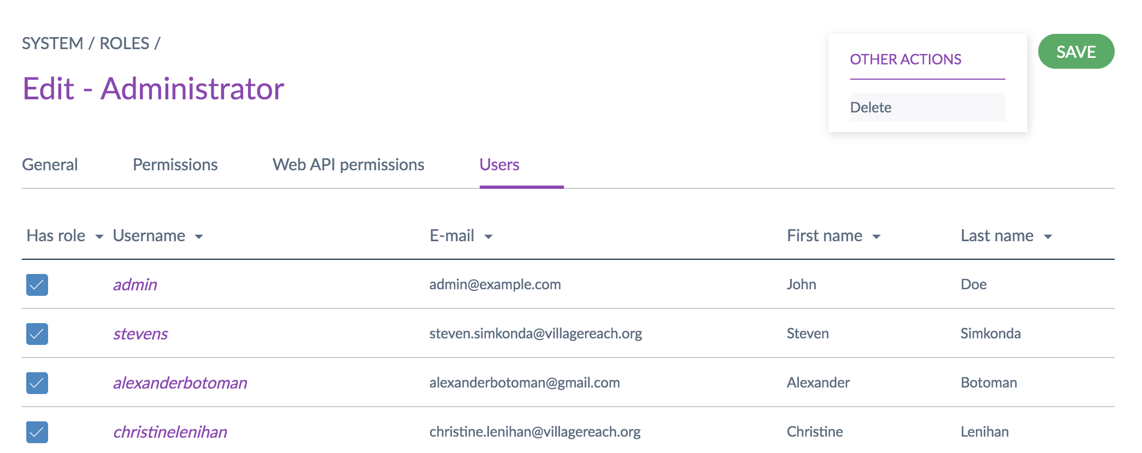
2
1
3
- From the edit role page (follow steps 1-3 of section 4.2.1.2) click USERS to see if any users are assigned the role (if so, ensure they are assigned other roles to provide the required access).
- Click on the 3-DOT MENU (…) to the left of the save button
- Click DELETE
Figure 59: Confirm Deletion
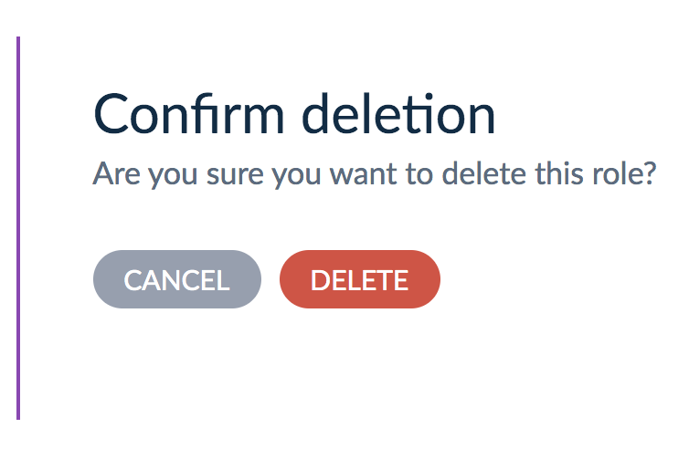
4
- Click CONFIRM to confirm the deletion of the role

Creating User Accounts
A user is simply an account that provides access and credentials to the NPC. Unique users can be created for individual people (recommended for better security and if individual-level audit tracking for changes/approvals is desired) or more generic departmental/organizational accounts can be created and used by several people. Creating a user account requires a few basic elements:
- First name  - Last name  - Username* | - Password  - E-mail address  - Role assignment
* A standard username convention is recommended (i.e., first initial + last name; firstname.lastname etc.)
Follow the steps in this section to create a new user account.
Figure 49: User Management Page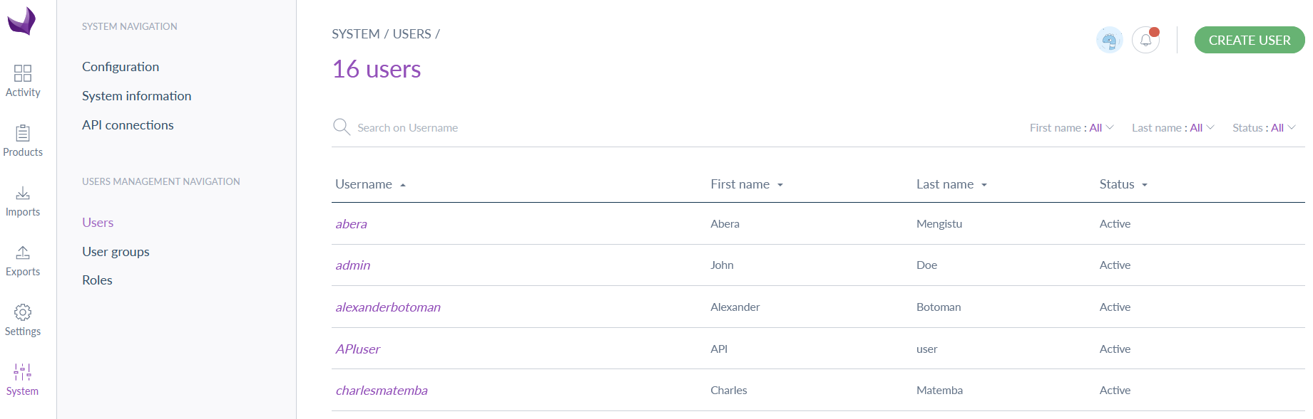
1
2
3
- Click on systems
- Click on Users
- Click on Create User
Figure 50: Create User
5
4

- Add user’s account details including username, password, first and last name, and e-mail.
- Click SAVE

Assigning User Groups & Roles
Once their accounts are created, users must be assigned roles to determine what functions they can access and perform. Users can also be added to groups for easier user management. Users must be assigned roles, as their role(s) will determine the actions they can perform in the system. A user does not need to be added to any groups. After the user has been created, follow the steps in this section to assign groups and roles. More information about creating roles and groups is included in sections 4.2.1 and 4.2.3, respectively.
Figure 51: User Management Page (Assign Roles)
1
2

- From the USERS page
- Click on the USERNAME of the desired user

Figure 52: Groups & Roles Page
- Click on GROUPS AND ROLES
3
6
5

4

- Click on the GROUPS field and select any groups the user should be added to
- Click on the ROLES field and select the role or roles to assign to the user
- Click on SAVE

Creating User groups
Users can be put into groups for easy user management. A user can belong to one or several user groups, for example, users with the same roles or from the same department/organization. By default, when a user is created, they do not belong to any user group. Follow the steps in this section to create a user group.
Figure 60: User Groups Screen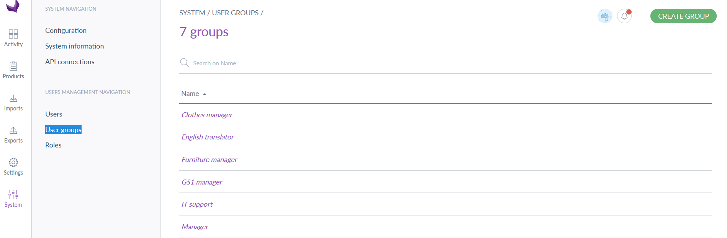
3
2
1
- Click on Systems
- Click on User groups
- Click on CREATE GROUP
Figure 61: Create Group
4
5
- Enter Group Name
- Click Save
After saving, you will be prompted to assign users to the newly created group.
Figure 62: Add Users to a Group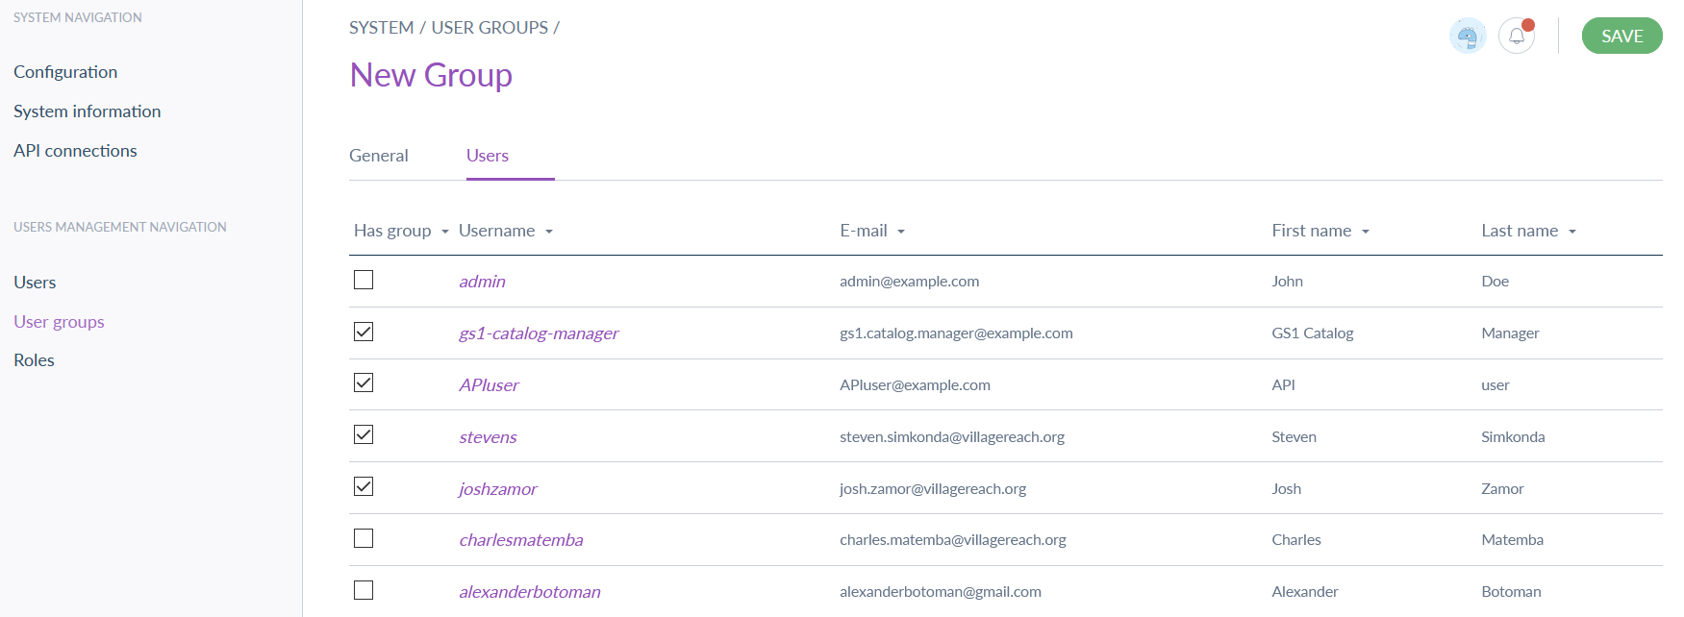
7
6
- Select all users to add to the group by clicking the CHECKBOX next to their username
- Click SAVE

Product Attributes
Attributes are characteristics of a product, for instance product image, product name, dosage etc. Attributes can either be created direct in the system interface or can be define in excel and just imported using the system import function (see section 3.9.1). The NPC system includes a set of predefined, standard attributes as well as allowing for the creation of new attributes. The table below lists the attributes for each family in the NPC.
Table 6: Attributes per Family in NPC
Family | Attributes
<Country> Products & Trade Items | - Product image  - Dosage form  - Route of administration  - GTIN  - GS1 brand name  - GS1 functional name  - <Country> master product code  - <Country> class serial number  - <Country> new product code  - <Country> old product code  - Manufacturer name  - Country of origin | - Shelf life days  - GS1 manufacturer GLN  - GS1 manufacturer name  - GS1 child item  - GS1 packaging hierarchy type  - GS1 packaging hierarchy MW  - New item description  - <Country> product name  - Unit of issue  - Class code  - Quantity of children <Country>  - Unique ID
<Country> Products & Trade Items GTIN | - Product image  - Dosage form  - Route of administration  - GTIN  - GS1 brand name  - GS1 functional name  - GS1 country of organ  - Manufacturer name | - Shelf life days  - GS1 manufacturer GLN  - GS1 manufacturer name  - GS1 child item  - GS1 packaging hierarchy type  - GS1 packaging hierarchy MW  - Unique ID
This section provides information on key attribute management functions. Additional information is available on the PCMT Wiki.

Attribute Types
Attributes are categorized into various types, which dictates what parameters, options, and validation is relevant to the specific attribute. The table below provides a list of key attribute types for the NPC (more detail is available on the Help Site).
Table 7: Attribute Types
Attribute Type | Description
Identifier | A code to identify your product, this code must be unique. It can be a SKU, an MPN. This attribute is mandatory to create products.
Text | A single-line text field that can contain up to 255 characters, it is usually used for a product name.
Text area | A multi-line text field that can be used for a product description.
Simple select | A single-choice list coming with custom options. Only one value can be selected amongst the available options.
Multi select | A multi-choice list coming with custom options. More than one value can be selected amongst the available options.
Yes/No | A Boolean attribute.
Date | A date field that will display a calendar to choose the date, which includes day, month and year.
Number | A single-line field that can only contain digits.
Metric | A single-line field composed of a 1st field containing a number and a second field containing a metric unit. It allows you to automatically convert metric values into others to fit your export needs.
Price | A price attribute with values per currency. The displayed values will depend on the currencies enabled.
Image | A drag and drop down zone to upload an image (extensions allowed: gif, jfif, jif, jpeg, jpg, pdf, png, psd, tif, tiff) .
File | A drag and drop down zone to upload a file (allowed extensions: csv, doc, docx, mp3, pdf)
Reference data simple select | Allows you to manage any kind of data that has its own properties, as a single-choice select.
Reference data multi select | Allows you to manage any kind of data that has its own properties, as a multi-choice select.

Creating Attributes
Follow the steps in this section to create a new attribute in the NPC.
Figure 63: Settings - Attributes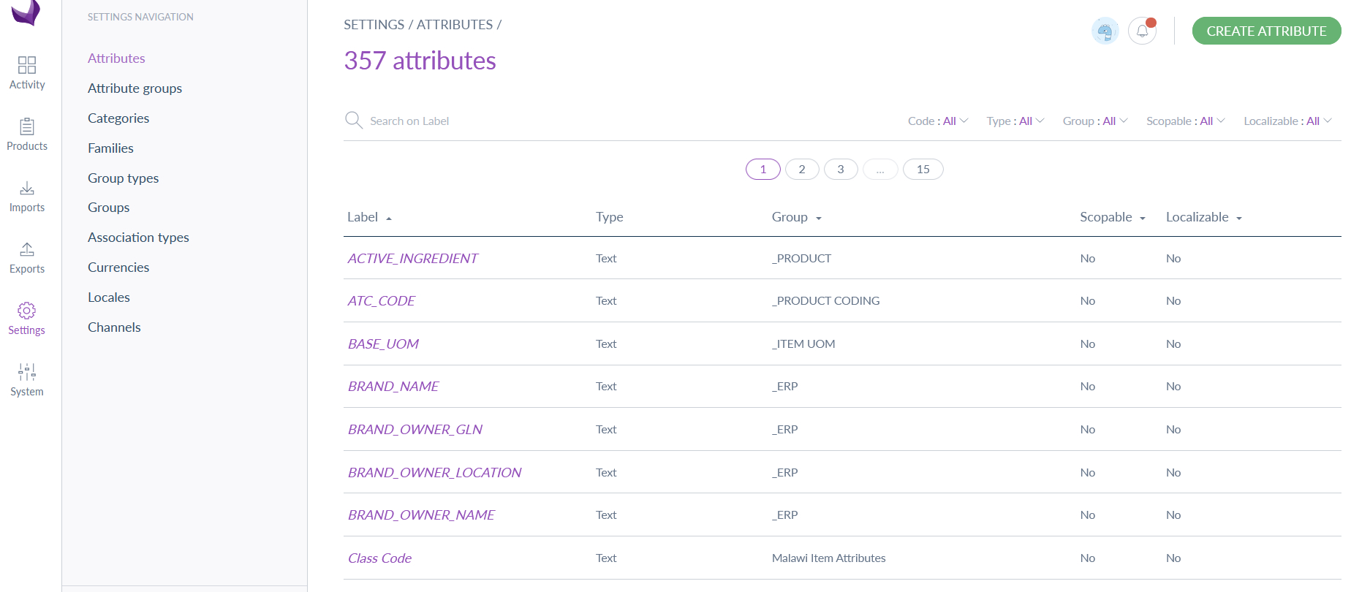
1
2
3
- Click on SETTINGS
- Click on ATRIBUTES
- Click on Create Attribute
Figure 64: Select Attribute Type
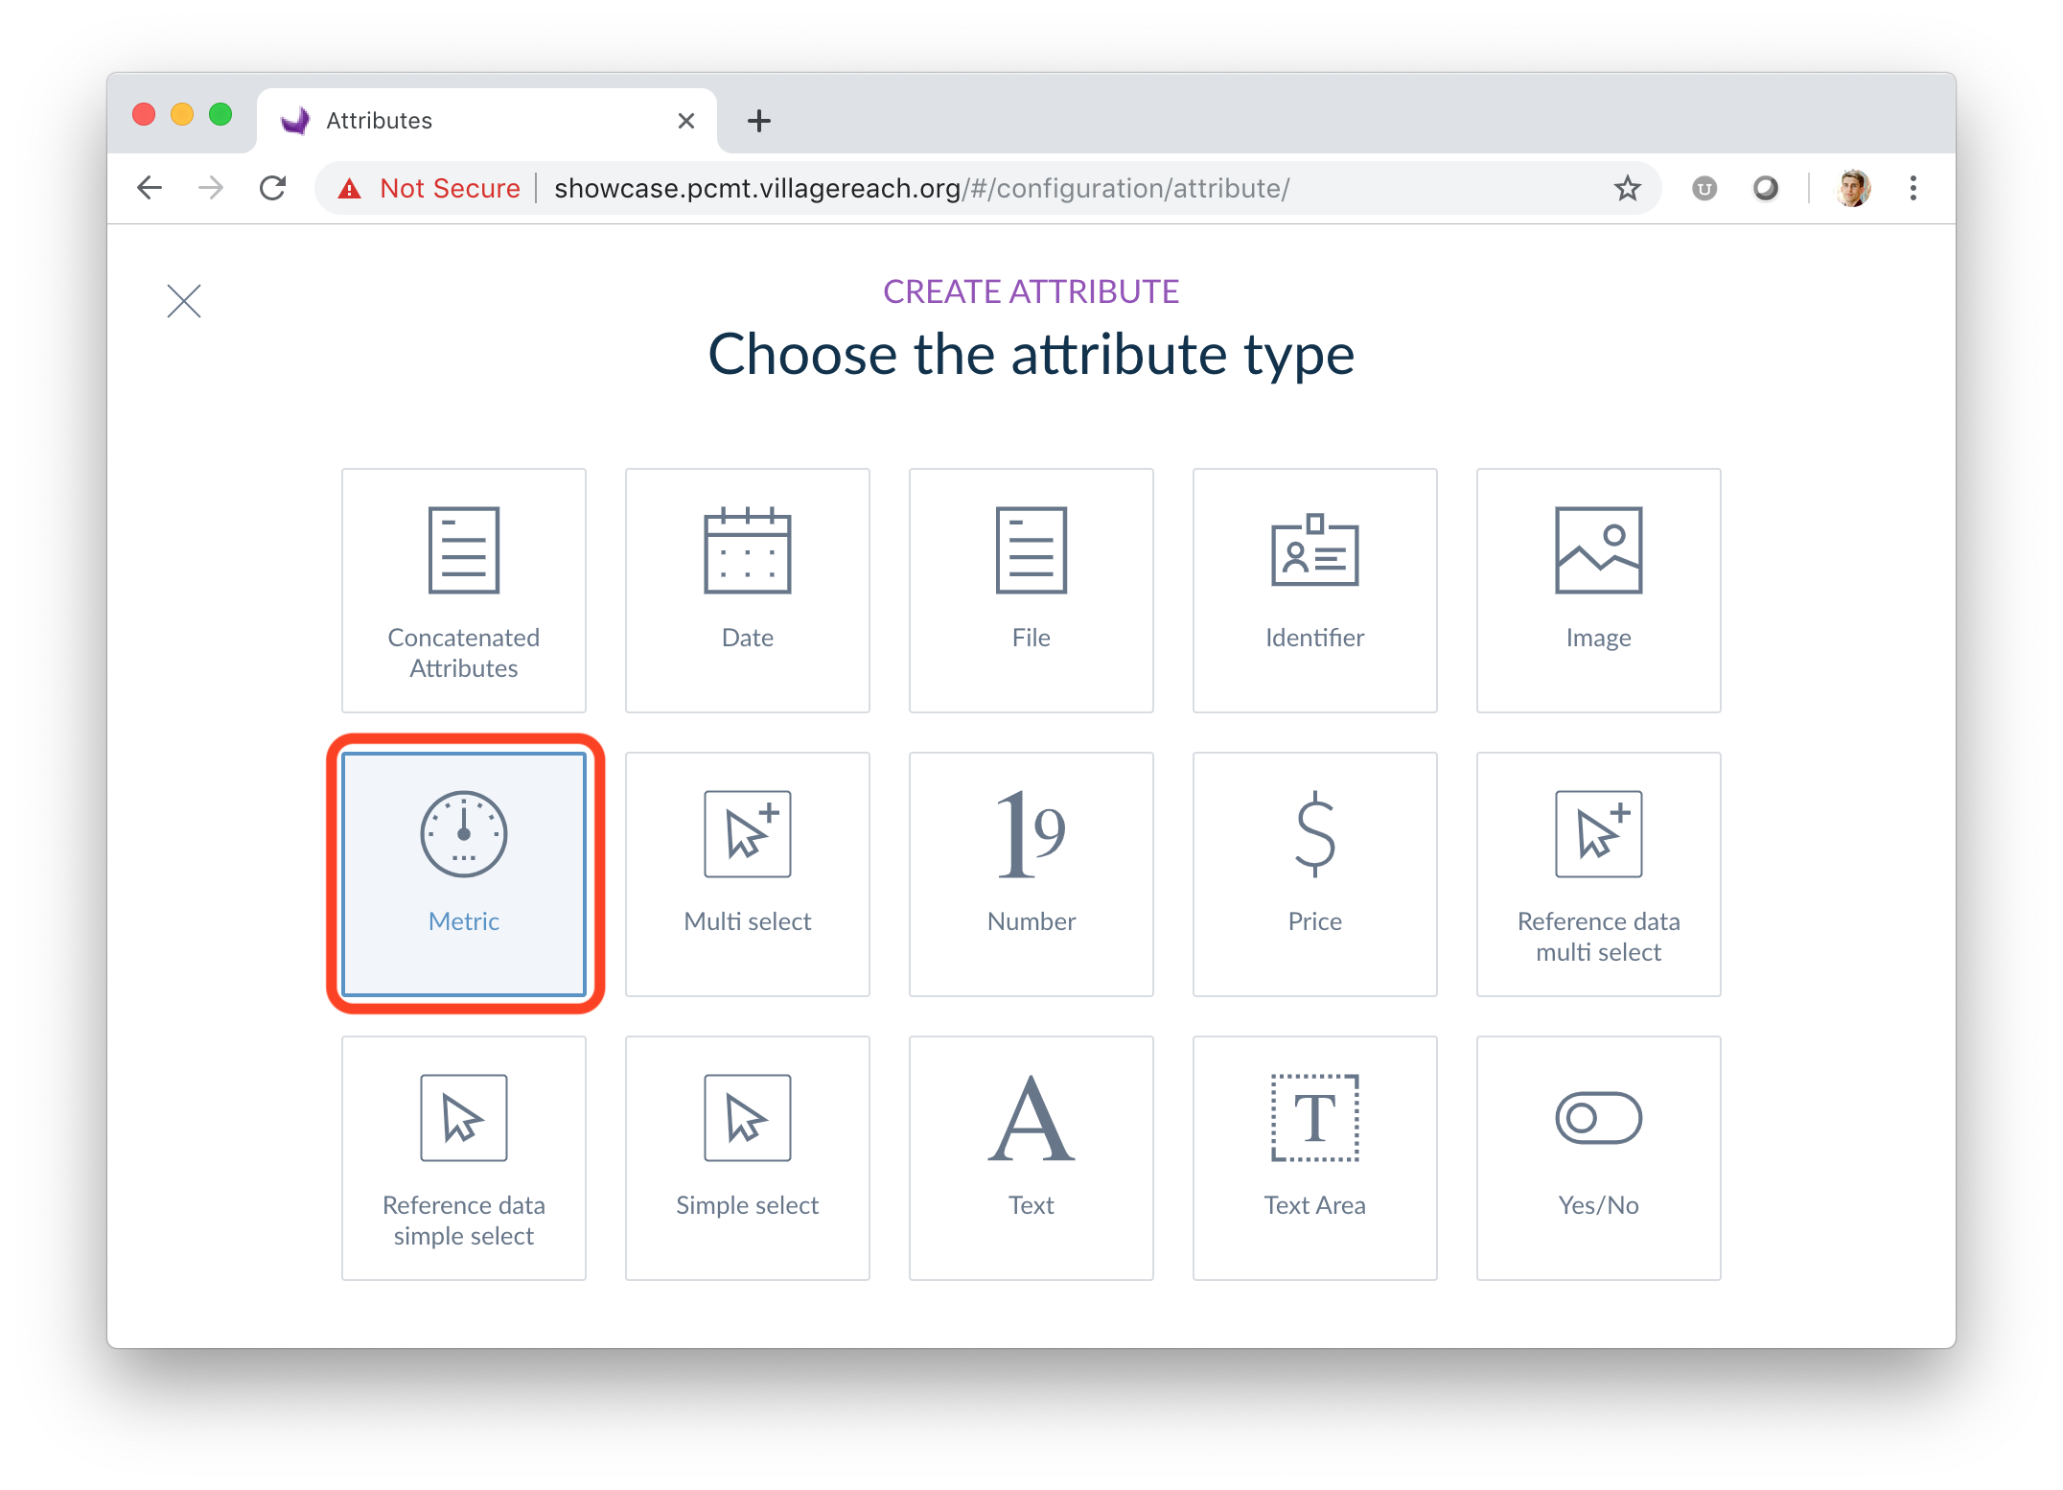
4
- Click on the attribute Type (see section 4.3.1); for example, the Metric type.

Figure 65: Create Attribute
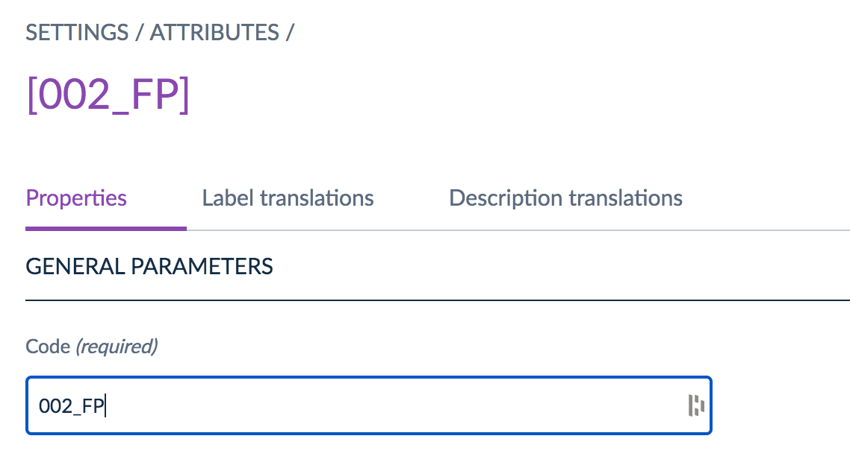
5

- Add a CODE

Figure 66: Set Attribute Parameters
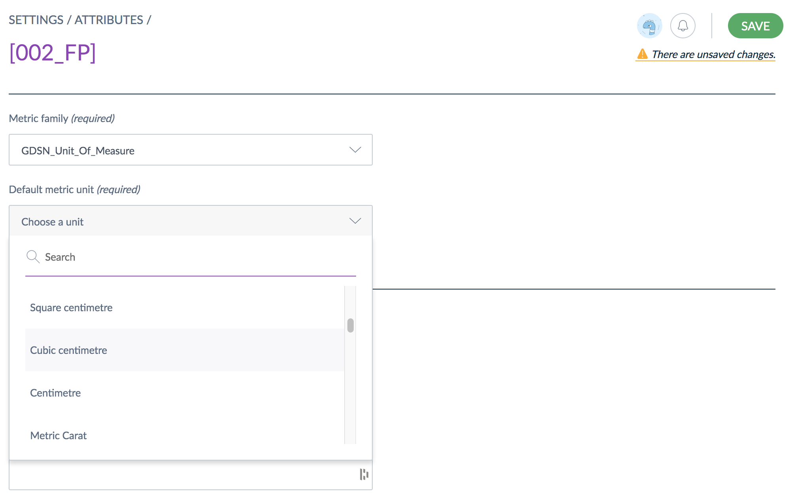
8
7
6
- Add PARAMETERS for the selected attribute type. The available parameters and options for each will vary based on the attribute type.
  - For the metric example, a METRIC FAMILY is required
- Complete all required and desired parameters for the attribute
- Click SAVE

Adding Descriptions to Attributes
The NPC includes a localizable description field for attributes. If defined, the localized definition will appears below the attribute when users are editing a product. Follow the steps in this section to add a description to an attribute.
Figure 67: Add Attribute Description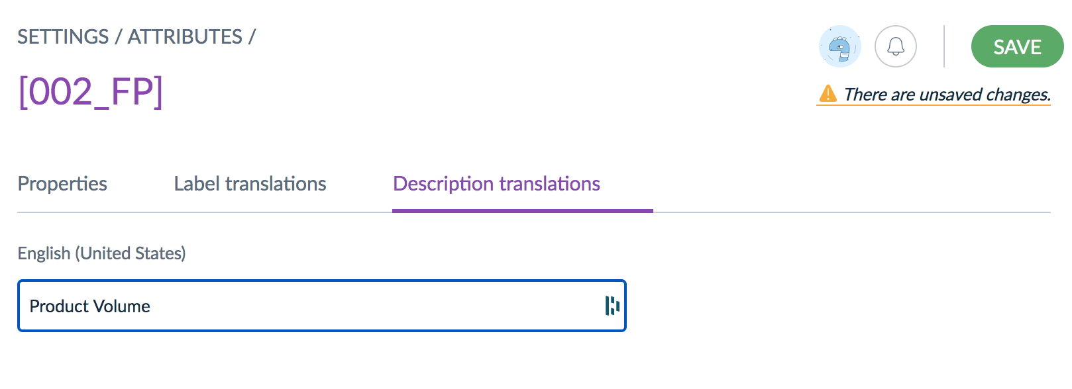
1
2
3

- From the Edit Attribute screen (follow steps 1-4 of section 4.3.2 or select and existing attribute to edit), click DESCRIPTION TRANSLATIONS
- Enter the DESCRIPTION (you can add 1 per active location)
- Click SAVE

Validation Parameters
To help ensure data quality and accuracy, the NPC system has data validation capabilities that can be applied when creating attributes. Each attribute type has specific properties (see the table below) that can be set to control acceptable attribute values, to ensure product data is entered consistently and accurately. If, for example, the class code for the MHPL products was never more than 6 characters/digits long, a Max Characters validation parameter could be set for the Class Code attribute. This
Table 8: Attribute Type Validation Parameters
Attribute Type | Validation Parameters
Date | - Min date: the earliest date that can be accepted  - Max date: the latest date that can be accepted
Text | - Maximum number of characters: maximum number of characters that an attribute value can have  - Validation rule: how the value should be validated: such as an URL, as an Email, or using a regular expression
Text area | - Maximum number of characters: maximum number of characters that an attribute value can have  - Enable WYSIWYG: activates the WYSIWYG feature
File / Image | - Maximum size allowed in MB  - Allowed extensions files
Metric | - Allow negative values for the attribute  - Allow decimal values for this attribute  - Minimum value: the smallest value allowed  - Maximum value: the largest value allowed  - Metric family: family measurement unit to be used for the attribute (weight, dimensions, area, etc.)  - The default unit of measurement
Price | - Allow decimals for the attribute values  - minimum value: the smallest allowed value  - maximum value: the largest allowed value
Number | - Allow negative values for the attribute  - Allow decimals  - Minimum value: the smallest allowed value  - Maximum value: the largest allowed value
Reference data simple select / Reference data multi select | - Reference data type: choose an existing reference data to link to your attribute.
Validation parameters for the specific type of attribute are located on the Attribute Properties page and can be set along with the other attribute parameters (follow steps 6-8 of section 4.3.2).

Grouping Attributes
Attributes can be grouped according to their use or type etc. to be more easily used and applied. Follow the steps in this section to group attributes.
Figure 68: Attribute Groups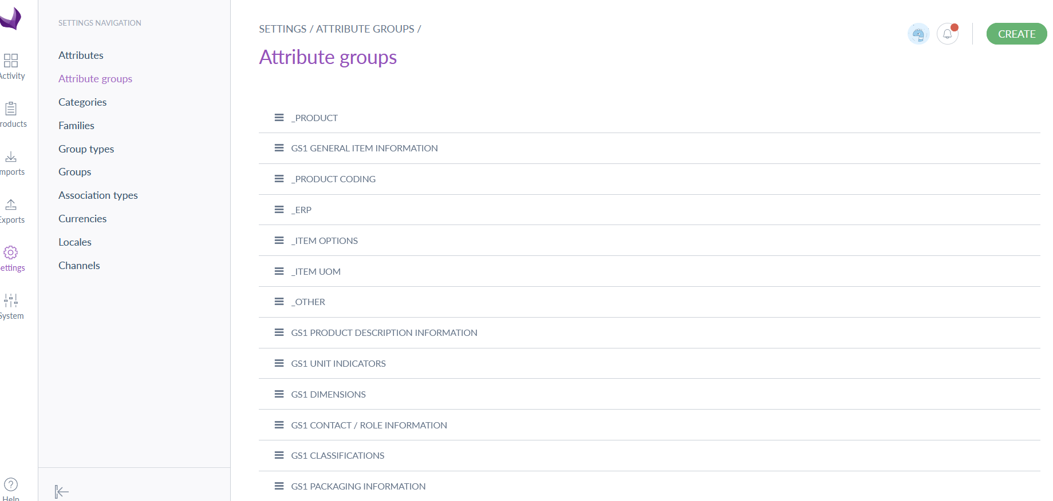
1
3
2
- Click on SETTINGS
- Click on ATTRIBUTE GROUPS
- Click on CREATE (to modify an existing group, click on the group name instead and skip to step 5)
Figure 69: Create Attribute Group
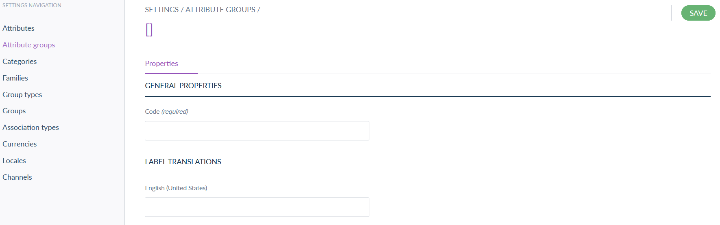
4
5
- Add the group CODE or name
- Click SAVE
Figure 70: Add Attributes to Group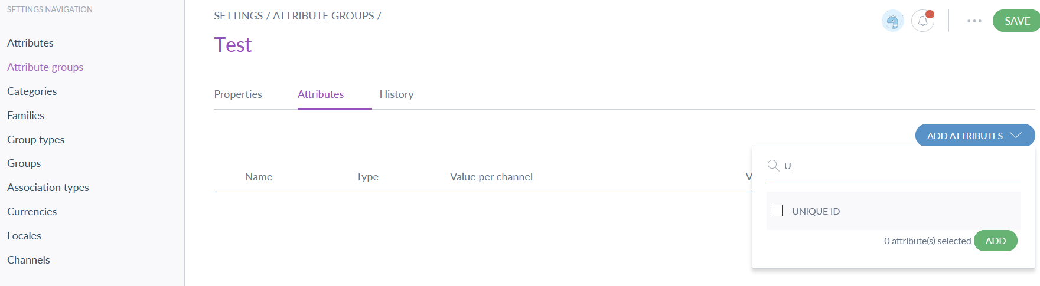
6
7
8
9
10
- Click on the ATTRIBUTES tab
- Click ADD ATTRIBUTES
- Find and select the attributes to be added
- Click ADD
- Once all attributes are added, click SAVE to save the group

Delete an Attribute Group

If you want to delete an attribute group, follow the steps in this section.
Figure 71: Select Attribute Group
1
- From the Attribute Group screen (follow steps 1-2 in section 4.3.3) click on the ATTRIBUTE GROUP

Figure 72: Delete Attribute Group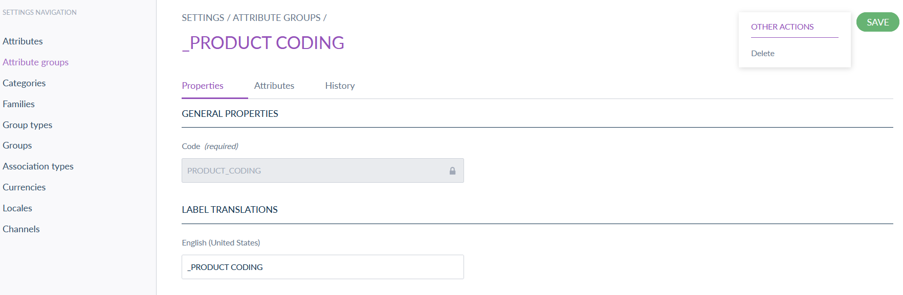
2
3
- Click the 3-DOT MENU (…) to the left of the save button
- Click DELETE

Create Categories
Categories are used to group and classify products/items. Categories can have multiple sub-categories. More detail is available on the Help Site. Follow the steps in this section to create a category.
Figure 73: Manage Categories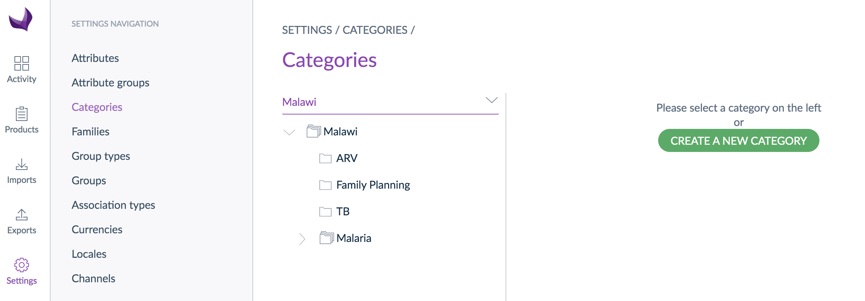
1
2
3
- Click on Settings
- Click on Categories
- Click on Create a new category
Figure 74: Create Category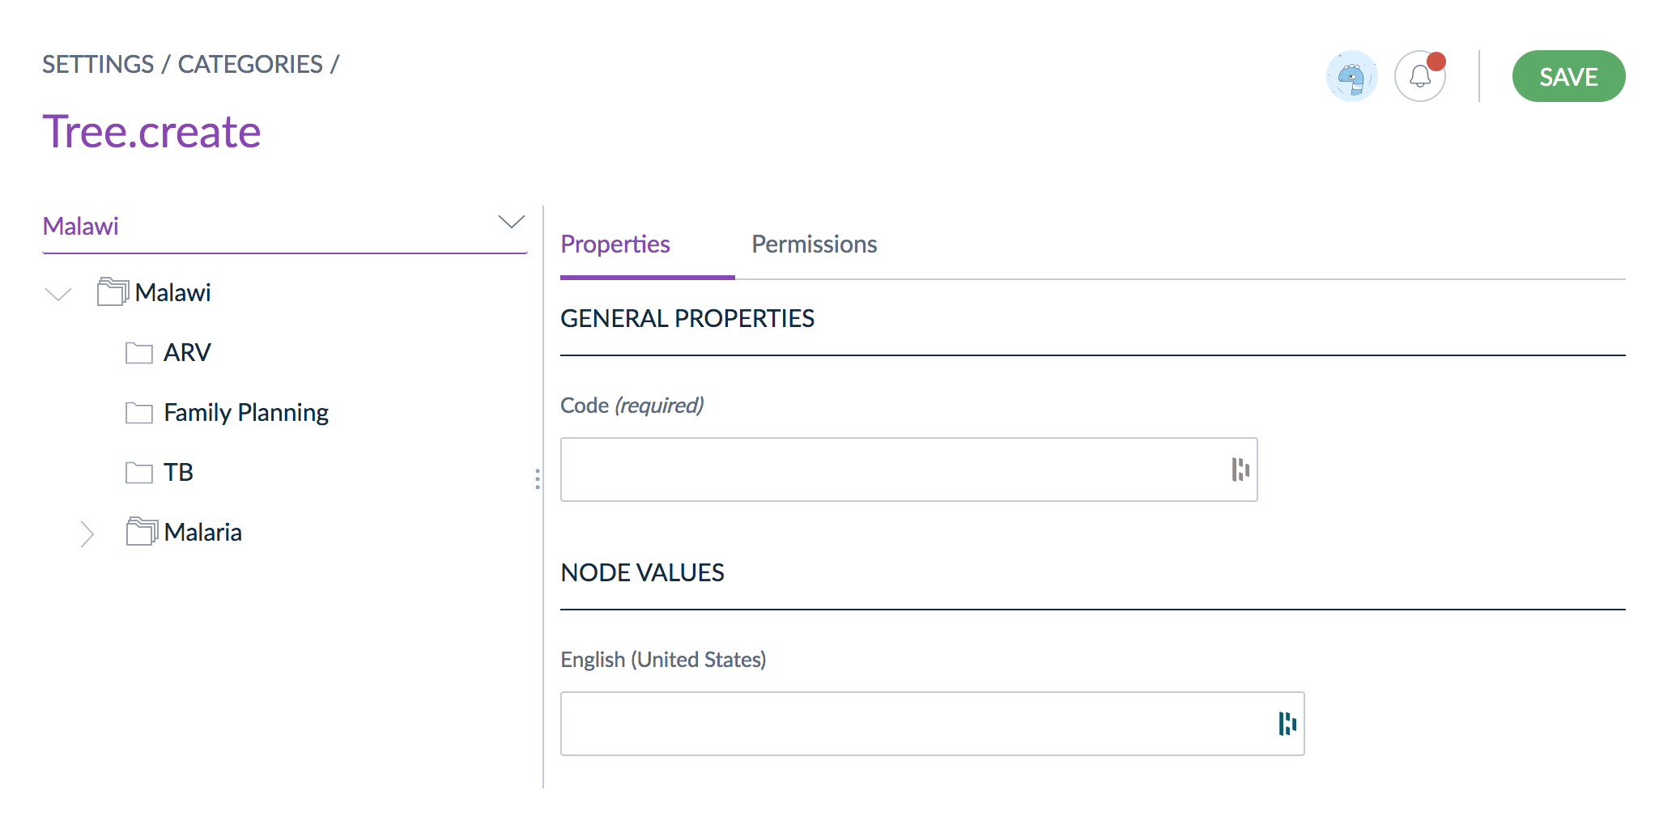
4
5
- Add a CODE
- Click permissions
Figure 75: Set Category Permissions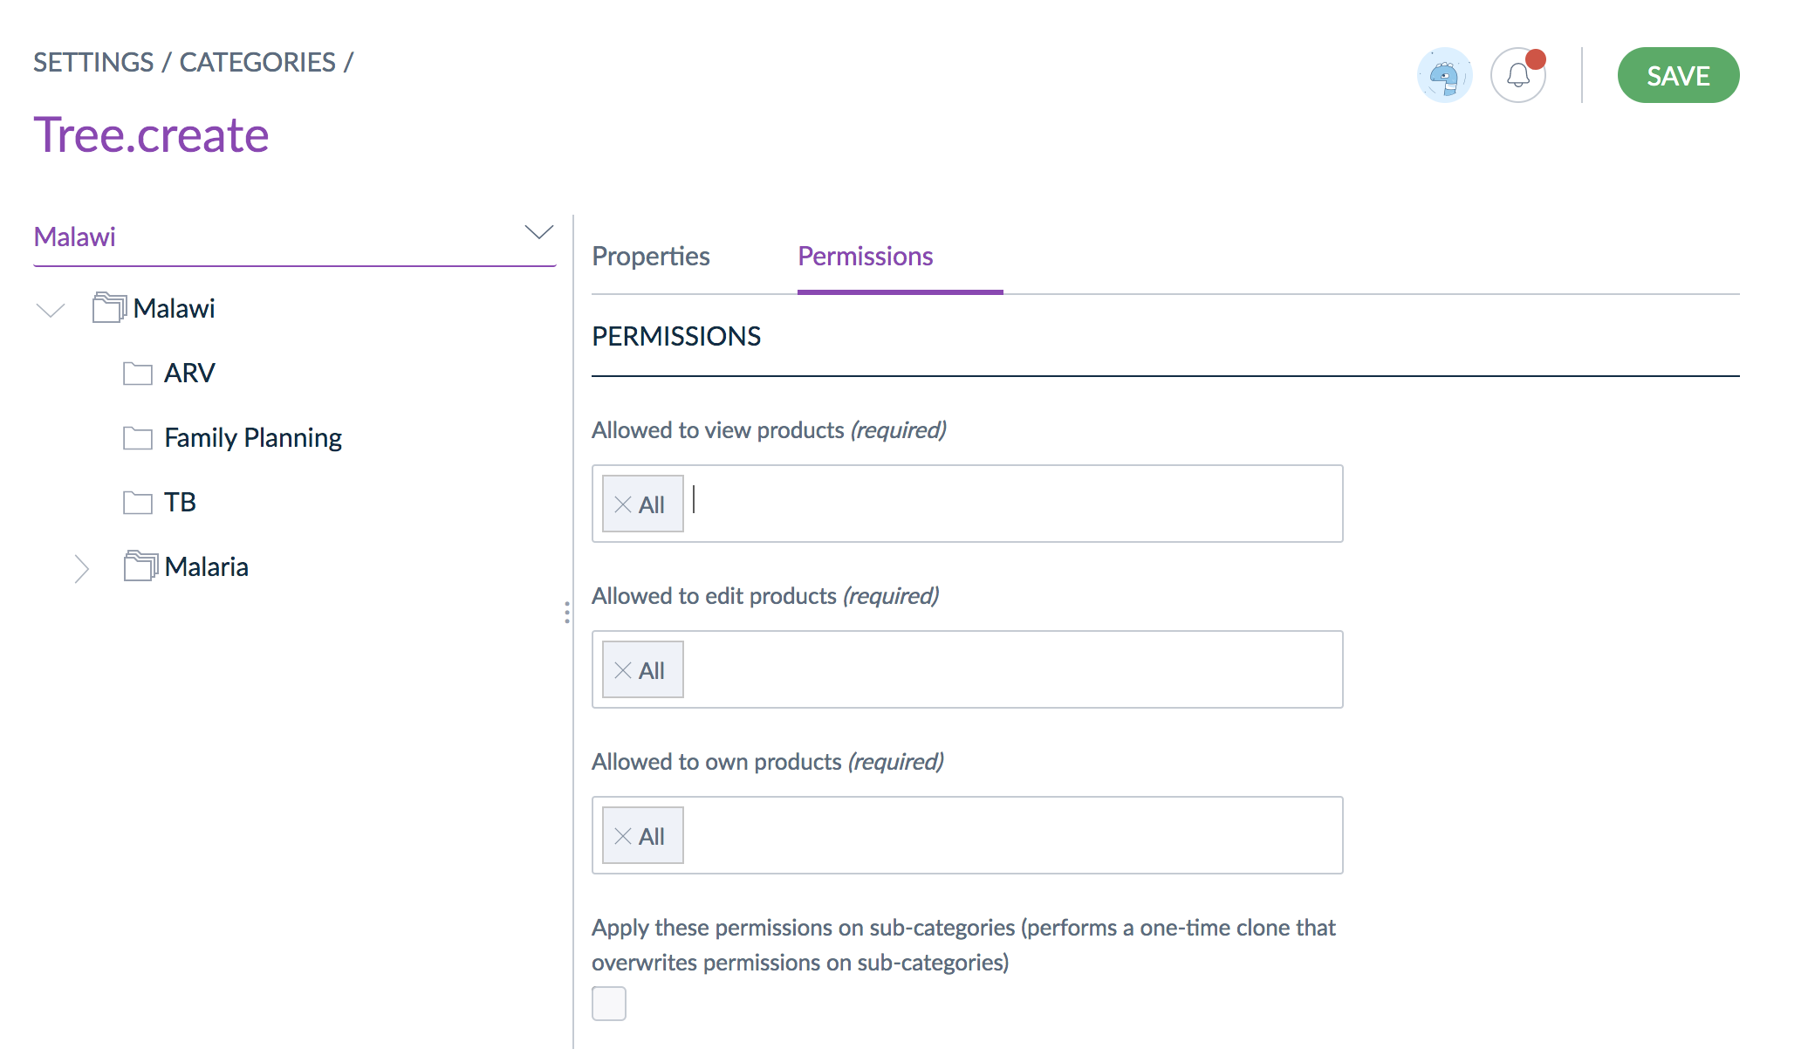
6
7
- All roles are included by default. If desired update permissions by selecting the specific roles able to view, edit, or own products in the category
- Click save.

Create Sub-Categories
Follow the steps in this section to create sub-categories in an existing category tree.
Figure 76: Category Tree
1
- From the Categories screen (follow steps 1-2 of section 4.4) RIGHT CLICK an existing category or sub-category and click CREATE
Figure 77: New Sub-Category
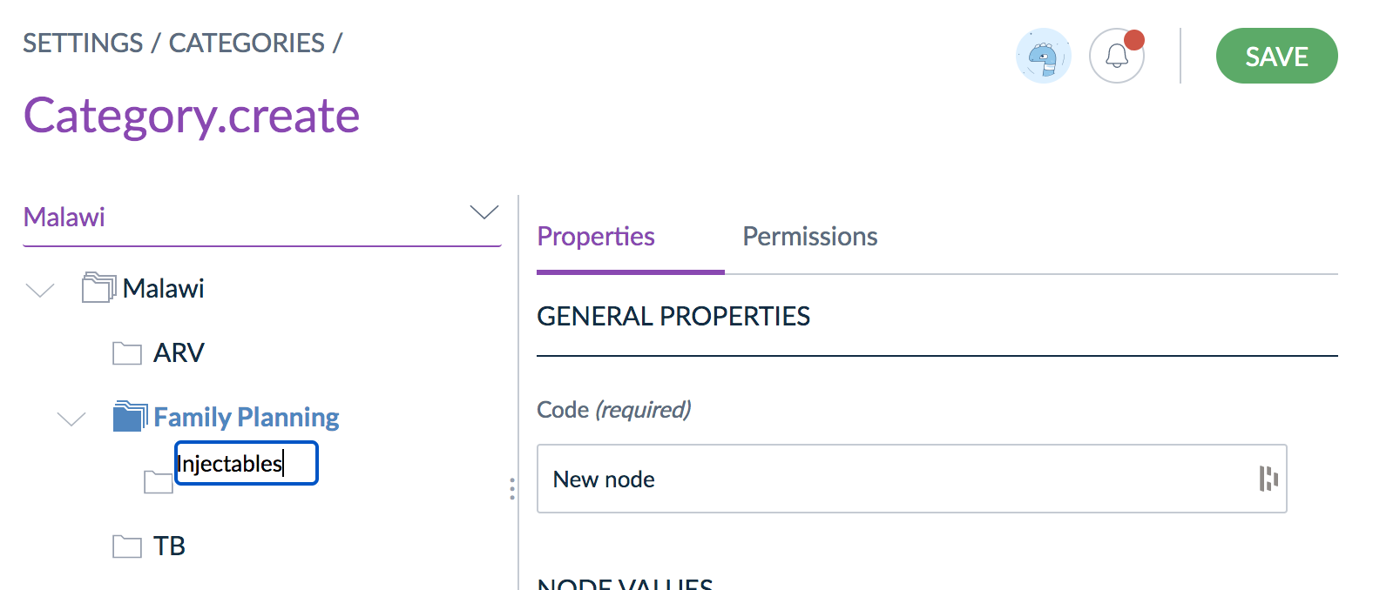
2
3
- Enter the NAME of the new sub-category
- Click SAVE

Manage Import & Export Profiles
Import and export profiles are used to define properties and permissions used to import and export data. The profiles define the data and data elements included in the import/export files.

Import Profiles
Import profiles are used to govern product or configuration data being imported, or uploaded, to the NPC. Follow the steps in this section to create import profiles.

Create Import Profile
Follow the steps in this section to create a new import profile (see Help Site for additional detail).
Figure 78: Import Profiles - Create
1
2
- Click IMPORTS
- Click CREATE IMPORT PROFILE
Figure 79: Create Import Profile
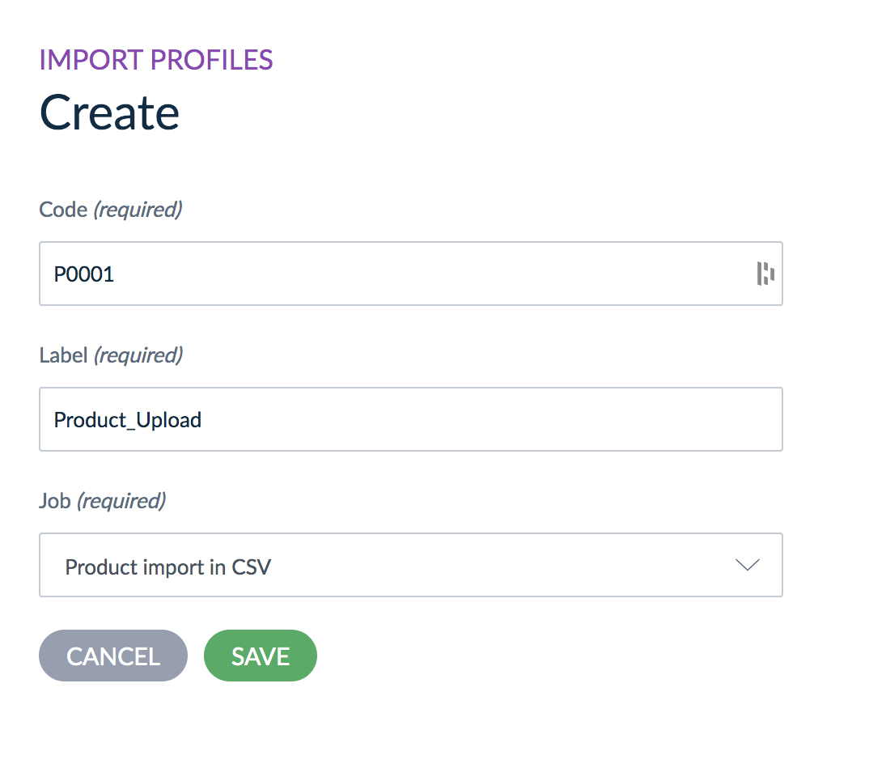
3
5
4
6

- Add a CODE
- Add a LABEL
- Select the JOB to indicate what data this profile will import
- Click SAVE

Edit an Import Profile
Follow the steps in this section to edit an existing import profile.
Figure 80: Edit Import Profile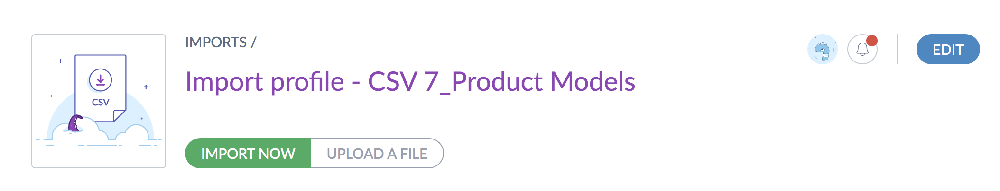
1
- From an import profile (follow steps 1-2 from section 3.9.1), click EDIT

Figure 81: Edit Import Profile Properties & Settings
2
3
- Make required updates to PROPERTIES and GLOBAL SETTINGS (available settings vary based on the import job – see table 9)
- Click SAVE
The properties and settings included in the import profile depend on the import job. Table 9 provides a list of common properties.

Table 9: Common Import Profile Properties
Property | Details
File path | Defines the path of the file to import in the case you want the PIM to automatically fetch the file for you
Allow file upload | Allows file upload from the specified file path in the case you want the PIM to automatically fetch the file for you
Delimiter | Defines the character to delimit the fields in the file (semi-colon, comma...)
Enclosure | Defines the character for the field enclosure in the file (“)
Decimal separator | Defines the character used as decimal separator in the imported file (for instance a dot, a comma.)
Date format | Defines the format used for dates in the imported file (for instance yyyy-mm-dd, mm/dd/yyyy...)
Enable the product | Defines the default status to create a product:  - status “enabled” if yes  - status “disabled” if no
Categories column | Defines the column name for categories in the imported file
Family column | Defines the column name for family in the imported file
Groups column | Defines the column name for groups in the imported file
Compare values | Enables the comparison between original values and imported values  It can speed up the import if imported values are very similar to original values
Real time history update | Enables the update of the product history  It can be switched off to improve performance

Automated Imports
The NPC system supports automated imports to automatically load and update product data from external sources. Pre-defined import profiles are available for several common international or global standard product data sources:
- Global Family Planning Visibility and Analytics Network (GFPVAN) catalogue
- Manufacturer data via GS1 GDSN on E2Open Data Pool
See the PCMT User Documentation for more details on the set up and use of these import profiles.

Export Profiles
Export profiles are used to govern product or configuration data being exported from the NPC. Follow the steps in this section to create export profiles.

Create Export Profile
Follow the steps in this section to create a new export profile (see Help Site for additional detail).
Figure 82: Export Profiles - Create
1
2
- Click EXPORTS
- Click CREATE EXPORT PROFILE
Figure 83: Create Export Profile
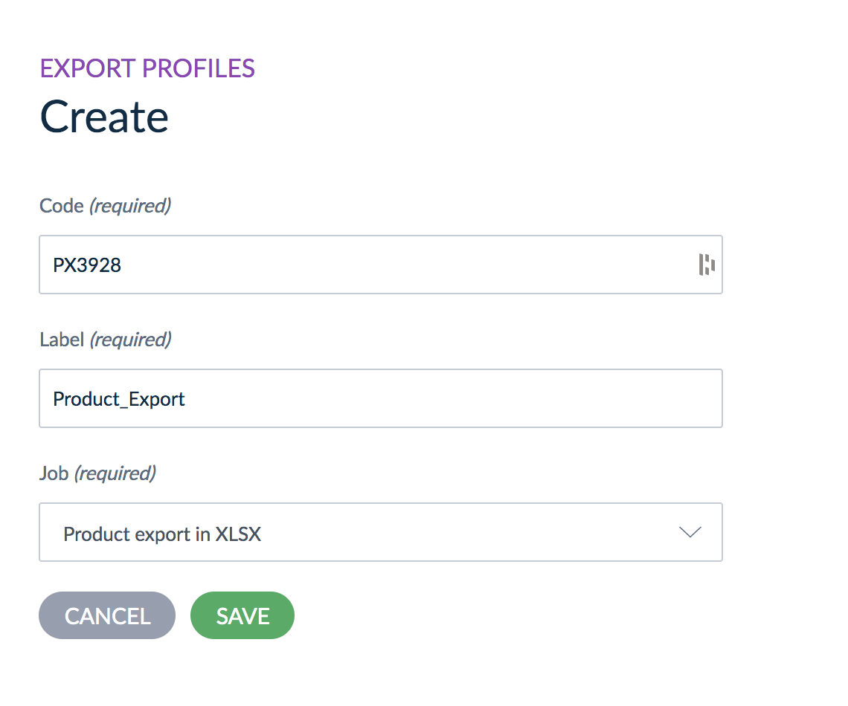
6
3
4
5

- Add a CODE
- Add a LABEL
- Select the JOB to indicate what data this profile will import
- Click SAVE

Edit an Export Profile
Follow the steps in this section to edit an existing export profile.
Figure 80: Edit Export Profile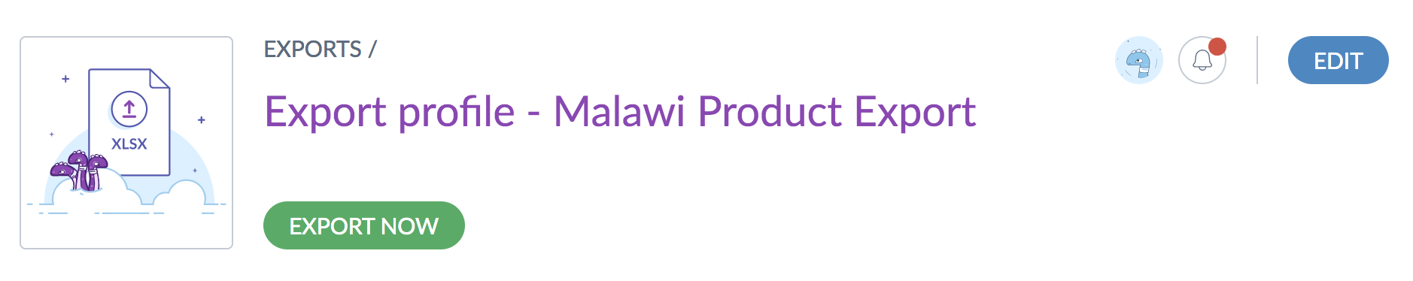
1
- From an export profile (follow steps 1-2 from section 3.9.2), click EDIT

Figure 81: Edit Export Profile Properties, Settings, & Content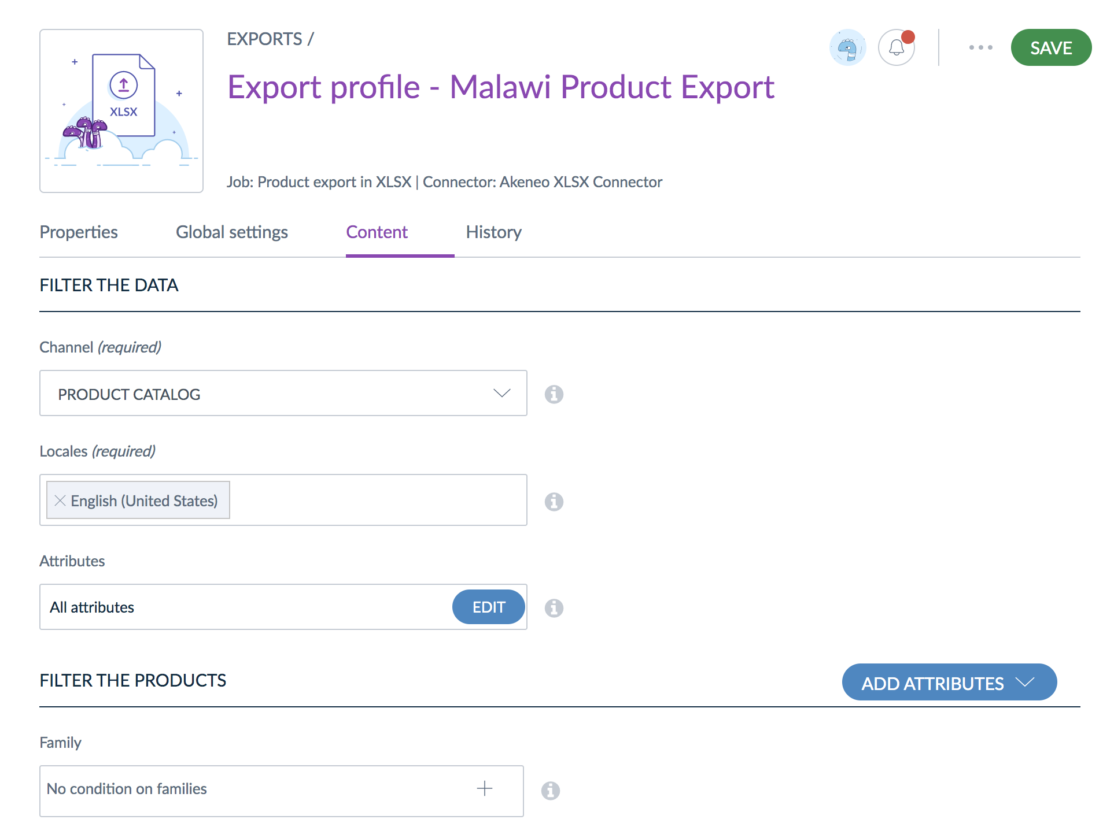
2
3
- Make the required changes to the PROPERTIES, GLOBAL SETTINGS, or CONTENT (properties, settings, and content vary based on the export job)
- Click SAVE

Predefined Export Profiles
The NPC system includes predefined export profiles and features to export product catalogue data into E2Open-supported XLS formats for sharing with other catalogues (such as GFPVAN). There are two specific export file formats supported: Pcmt e2open export and Pcmt mst supplier export. The first provides a list of products, and the second provides a list of suppliers. See the PCMT User Documentation for more details on the set up and use of these export profiles.

Data Collection

Data Sources
This section provides an overview of NPC data sources for trade-item/branded-item, GTIN level data. The item data in PCMT has three main sources:
- Physical Packages - Two methods were used to collect product data directly from physical packages
  - GSI mobile barcode app: A GS1 mobile barcode scanner application installed on a smartphone or tablet can be used to scan a single item per product. This can be hierarchical (package scan and inner product scan) or only an inner pack scan. The scanned list can then be exported with images for data import or entry into NPC (see the data collection export and links to user registration and the application user guide in Appendix 4; section 6.4).
  - Excel template: Product information can also be collected from warehouses or district stores using a provided excel template with instructions in Appendix 5 (section 6.5). This data can also be entered directly into NPC or formatted and imported.
- Manufacturers - Product data can be collected directly from manufacturers who are mandated to submit their product information to CMST through an approved excel template (see the request letter for product data from manufacturers in Appendix 3; section 6.3). The document can be formatted in accordance with the NPC product template and then imported or entered directly.
- Donors - Product data can also be collected from donors who procure products from manufacturers. This information may be provided in various formats, but could be formatted in a spreadsheet for import or entered manually.

Appendices

Appendix 1 PCMT Installation 1.0 User Documentation
The PCMT system selected for use to manage and maintain <Country> ’s NPC has available user documentation, as does the Akeneo system on which PCMT is built. Key documentation and resources are available:
- PCMT 1-Page Overview
- PCMT User Documentation
- PCMT Quick Start Guide
- Deploying PCMT
- Akeneo Design Elements

Appendix 2 Catalogue Manager Job Description

Catalog Manager Role
Description:
Catalog Manager role is responsible for the management of product/item master data and supports the strategic development of the National Product Catalog (NPC) solution as a resource for the wider public health community. The Catalog Manager serves as the primary point of contact for all health commodities’ product/item master data. The role also incorporates strategy regarding the transition of the product/item master data from its legacy system and processes to the National Product Catalog. The responsibilities of this role have been detailed below.
Primary Responsibilities:
- Establish product master data governance (SOPs) for all health commodities
  - Define and maintain SOPs that establish product/item master data governance policies including agreed and approved mechanisms to add, update or delete products/items
  - Define roles and responsibilities for maintaining timely and accurate master data as part of the data governance process
  - Define security roles in NPC
- Populate and maintain product/item master data in NPC for all assigned health commodities
  - Upload or enter product/item master data and mappings with country identifiers into NPC
  - Validate that populated data is complete and accurate
  - Ensure continued functionality of NPC in terms of product categorization, linkages to country identifiers, attributes grouping and data security
  - Collaborate with relevant stakeholders including regulatory staff and operational staff to identify new product/item additions, product/item updates, phase-outs, recalls and registration expiries and take appropriate actions to keep data up to date and accurate
- Facilitate on-going management of product/item master data in NPC
  - Monitor data quality and troubleshoot data quality issues
  - Add, delete, edit master data when changes are needed
  - Liaise with product/item data sources and data consumers in support of data governance SoPs
- Support data exchange across all applicable supply chain levels in the country
  - Collaborate across teams, organizational units, and external stakeholder groups
  - Facilitate and monitor product/item master data flow between NPC and other systems
  - Resolve data exchange and integration issues as necessary
  - Communicate any technical issues to NPC System Administrator
- GDSN synchronization strategy
  - Provide strategic support regarding adoption of GDSN integration in the long-term to source GS1 based item master data directly from manufacturers through GDSN
- Conduct data quality assessments and adjustments

Skills/Training
Required
- Experience managing healthcare product data
- Comfort in navigating product information management (PIM) information technology solutions

Desired
- Degree in data science, informatics, pharmacy or equivalent
- Certificate in pharmacy informatics or equivalent training
- Degree in pharmacy
- Knowledge of GS1 standards with specific experience in implementation of solutions using the Global Data Synchronization Network

Appendix 3 Letter to Manufacturers

[DATE]

To: [insert donor name]
[insert donor contact]
[insert donor address]

From: Ministry of Health, <Country>
Sharing GS1 based Item Master Data along with GTINs
One of the key objectives of the Ministry of Health is to ensure the safety, quality and efficacy of health commodities while eliminating counterfeit pharmaceutical products from health supply chain. Traceability of health commodities is a critical step in achieving these objectives. In order to effectively trace health commodities, all the way from manufacturer to end consumers, the Ministry of Health needs access to standardized and accurate item master data.
Item Master Data include health products’ Global Trade Item Numbers, which uniquely identifies products across the entire supply chain, and other attributes that define the product distinctively. As the Ministry of Health adopts GS1 standards to manage health supply chain within <Country> , accessibility to GS1 based item master data is a critical first step. Standardized GS1 based item master data will,
- Help us improve operational efficiency, data quality and accuracy by being able to leverage GS1 barcodes on commodity packages
- Enable our in-country systems to interoperate with each other and with global platforms to share standardized data in a timely manner thus improving overall supply chain efficiency
- Ensure safety, quality and efficacy of health commodities by enabling commodity traceability
In support of these objectives, the Ministry of Health seeks your organization’s support in providing us GS1 based item master data, at a minimum for those attributes listed in Attachment 1, for all commodities supplied by your organization to <Country> . This data can be shared in a spreadsheet through email to <email address>.

[Signature]
By:
Name:
Title:
Date:

Appendix 4 GS1 Data Upload Extract
This export was generated from a survey used to collect data using the GS1 Healthcare Barcode Survey mobile application, which enables users to capture GTINs and other basic item data from mobile barcode scans. User registration and the user guide are available on the application website.

AI | ID Key Value | ID Key Type | GEPIR Status | Description | Data owner | GLN of data owner | GCP | Address of data owner | Location of scan | Scan time | Survey name | First comment | User | Images | Record ID | Logger (GenSpec) status | Scanning environment | Survey - Location name | Survey - Location GLN
0 | 589042401010256000 |  | Valid |  |  |  |  |  | <Country> 9890900004540 | 2020-09-15T11:49:30 UTC +02:00 |  |  | (PSM <Country> ) | x | 98209 | Non standard | Regulated healthcare trade items
1 | 8906024342381 | GTIN | Valid |  |  |  |  |  | <Country> 9890900004540 | 2020-09-15T11:16:30 UTC +02:00 |  |  | (PSM <Country> ) | x | 98210 | Non standard | Regulated healthcare trade items
 | 8906062892374 | GTIN | Valid |  |  |  |  |  | <Country> 9890900004540 | 2020-09-15T11:11:42 UTC +02:00 |  |  | (PSM <Country> ) | x | 98211 | Standard | Regulated healthcare trade items
1 | 58907695010161 | GTIN | Valid |  |  |  |  |  | <Country> 9890900004540 | 2020-09-15T11:06:07 UTC +02:00 |  |  | (PSM <Country> ) | x | 98212 | Non standard | Regulated healthcare trade items
 | 8906045940375 | GTIN | Valid |  |  |  |  |  | <Country> 9890900004540 | 2020-09-15T10:50:07 UTC +02:00 |  |  | (PSM <Country> ) | x | 98214 | Standard | Regulated healthcare trade items

Appendix 5 Data Collection Form
Instructions: (PLEASE READ ME)

1. Collect all country specific product ids/codes etc. in Columns B & C. Add columns if there are multiple ids, as long as they map between each of the country ids.
2. Add rows if there are more than 1 GTIN per product/National ID/Code.
3. Capture Child Item (Column S) along with quantity of child packs within, if the package has GTIN/barcode for the child pack such as case within pallet, innerpack within case etc. Capture details of the child pack in the immediate next row as well as shown in below example
4. Use either a barcode scanner tool (wired or wireless) or an app such as 'Scan IT to Office' to scan barcodes in product packages into corresponding cell in Barcode Scan (Column G). If using Scan It to Office add Scan It to Office Add-In in Excel
Scan IT to Office Reference - https://www.youtube.com/watch?v=V3RveGIezcw
5. Capture additional details in columns K through V if readily available on the packaging, such as country of origin, manufacturer name etc.
6. Column I (Item Id (gtin)) is automatically filled based on the barcode scan into Column G (Barcode Scan). Columns F, H, J and M need to be selected from the predefined drop down list.
7. For Column V (Product Image), capture images of the product's corresponding package and either attach it here as an object or upload to google drive and attach link
# | National ID / Code | New product item code | Product Name /ID | Description | Product Bin Location | Donor | Barcode Scan | Barcode Type | Item Id  (gtin) | Hierarchy level  (tradeItemUnitDescriptorCode) | Brand Name  (brandName) | Functional Name  (functionalName) | Country Of Origin  (placeOfProductActivity/countryCode) | Product Description  (tradeItemDescription)
5 | FP004200 | FP-3430-0001 |  | Oral Contraceptive Tablets - Levonogestrel Only 0.3mg (Microlut) |  | USAID | 89040938000769400 | GS1-128 | 04093800076940 | (PK) Inner Pack | FAMY-POP | LEVONORGESTREL | 356 (India) | HealthChoice self care medicine
6 | FP004200 | FP-3430-0001 |  | Oral Contraceptive Tablets - Levonogestrel Only 0.3mg (Microlut) |  | USAID | 18904093820776 | Data Matrix | 18904093820776 | (EA) Each | FAMY-POP | LEVONORGESTREL | 356 (India) | HealthChoice self care medicine
7 | DN101000 |  |  | Artesunate Injection 60lm |  | USAID | 16920108100109 | GS1-128 | 16920108100109 | (CA) Case | artesun | artesunate | 156 (China) | HealthChoice self care medicine
8 | DN101000 |  |  | Artesunate Injection 60lm |  | USAID | 6920108100805 | GS1-128 | 6920108100805 | (PK) Inner Pack | artesun | artesunate | 156 (China) | HealthChoice self care medicine

Annex

Annex 1. Mobile Application Deployment & Configuration
The NPC mobile application can be downloaded from the Google Play Store or Apple App Store and used by an end user to easily get a product information by simply scanning a barcode on a product. The app. is connected to the <Country> NPC and it will retrieve the information (both product and country specific) for the user’s reference.
To configure the app. to connect to PCMT, application administrator will define the PCMT connection configuration as well as some customizations of the application user experience. Directions will differ in many steps depending on if the country desires to deploy an Android supported application or an IOS application. It is important to note however that the application can be deployed and distributed as either.

Signing up for services
The Mobile NPC application build process is easiest to run in Microsoft App Center. Sign up for a free App Center account here: https://appcenter.ms/
Android
To deploy an Android application, a user must have a Google Play Console developer account. This account will be used to request approval for your application and distribute it to Android users.
- Sign up here: https://play.google.com/apps/publish/signup/
- Before uploading an application, a user must pay a one-time fee of $25.00. After this fee, a user can upload applications for free.
IOS
To deploy an IOS application, a user must have an Apple app store developer account. This account will be used to request approval for your application and distribute it to IOS users.
- Sign up here: https://developer.apple.com/
- To list apps on the IOS App Store, a user must enroll in the Apple Developer Program. This costs $99/year

Creating PCMT Connection in PCMT
- Login to PCMT as a user with Admin permissions
- Navigate to the System sidebar menu
- Click Users Create User
- Enter in user information Save
- Click Roles Create Role
- Enter a name for the role, select Overall Web API Access under Web API permissions
- Select Users, select the user you just created and click Save.
- Click API connections Create enter a label click save
- Write down your client ID, client secret, username and user password for later use.
  - Refer to the documentation here for clarification a. https://api.akeneo.com/getting-started/your-first-tutorial-old/welcome.html
  - (OPTIONAL) Follow the instructions at that link to download the Postman collection and run test calls using the credentials you just created

Fork the application repository
Using a GitHub account, navigate to this repository and fork it into your own or your organizations GitHub account - https://github.com/JSI-ETH/Mobile-NPC
When running builds, you will be pointing to the code that you just forked. So, it is important to keep this code as updated as possible. Do this by pulling from upstream whenever there are production ready changes (indicated by the Ethiopia development team).

Create a JSON Blob
To easily set configuration settings for the Mobile NPC application, you will need to use a json blob.
Create a JSON Blob here - https://jsonblob.com/api/jsonBlob
Example configuration would be:
- Edit the settings, such as the attributes that you would like to pull from PCMT, to your uses.
- Save the API URL for your JSON Blob.

Creating application signatures
Android:
Follow the instructions here to create a keystore file - https://help.gamesalad.com/gamesalad-cookbook/publishing/4-android-publishing/4-02-creating-a-keystore/
IOS:
Follow the instructions here to request Signing files from Apple Developer Center - https://docs.microsoft.com/en-us/appcenter/build/ios/code-signing#:~:text=To%20sign%20your%20iOS%20builds,under%20Certificates%2C%20IDs%20%26%20Profiles.

Create an application build
- Under an organization, select Add new app
- Follow the instructions here to create a build - https://docs.google.com/document/d/1CWJTin0mFiY8R9KI7jfxsn-vFxQlQhmTZ03KZmS30vI/edit
- Use the GitHub repository that you previously forked as the code to point to during the build process. Currently you will need to point to the ‘development’ branch, but this will likely change in the future – so make sure to check with the Ethiopia development team about this as well as the environment variables below.
- In conjunction with those instructions, make sure to set these environment variables in the build process using data that you have generated/collected over the course of this process as the values
- Click Save and Build

Distribute Application
Android
To distribute the build that you just created to Google Play Store, follow these instructions
- https://docs.microsoft.com/en-us/appcenter/distribution/stores/googleplay

IOS
To distribute an IOS build to the IOS App Store, follow these instructions
- https://docs.microsoft.com/en-us/appcenter/distribution/stores/apple
To distribute a copy for testing purposes, follow these instructions.
- In App Center under your application, select ‘Distribute’ Releases
- New Release Distribute an Existing Build
- Select the branch that you previously built off of
- Select the build that you previously made
- Add release notes
- Add your own email or emails of other people that you would like to be able to test the app
- Review and complete
- For Android, this will email you an APK file that you open to download on your Android machine or in Android emulator.

https://wiki.ohie.org/display/SUB/GS1+Fundamentals
https://www.gs1.org/standards/id-keys/gtin
https://www.gs1.org/standards/id-keys/gln
https://www.gs1.org/services/gdsn
https://gitlab.com/pcmt/pcmt/-/wikis/Akeneo-design-elements
https://help.akeneo.com/pim/v3/articles/products-grid.html
https://help.akeneo.com/pim/v3/articles/what-about-products-variants.html#what-is-a-family-variant
https://help.akeneo.com/pim/serenity/articles/manage-your-users.html#deal-with-the-user-permissions
https://gitlab.com/pcmt/pcmt/-/wikis/Akeneo-design-elements
https://help.akeneo.com/pim/v3/articles/what-is-an-attribute.html#akeneo-attribute-types
https://help.akeneo.com/pim/v3/articles/what-is-a-category.html#how-to-create-a-new-category
https://help.akeneo.com/pim/v3/articles/imports.html#create-a-new-import-profile
https://docs.google.com/document/d/1DIWDSR-8MAKSHVc2JDlp0h4MdhSpnjEQFKT8y0WsPC8/edit#heading=h.vh79m1do9gl0
https://help.akeneo.com/pim/v3/articles/exports.html#create-a-new-export-profile
https://docs.google.com/document/d/1DIWDSR-8MAKSHVc2JDlp0h4MdhSpnjEQFKT8y0WsPC8/edit#heading=h.vh79m1do9gl0
https://docs.google.com/document/d/1DIWDSR-8MAKSHVc2JDlp0h4MdhSpnjEQFKT8y0WsPC8/edit#
https://docs.google.com/document/d/1zv8hhq8zpR1SNw5ssddCl10UpgsLuwd0s96BR5hRSNc/edit#
https://gitlab.com/pcmt/pcmt/blob/master/README.md
https://gitlab.com/pcmt/pcmt/-/wikis/deploy/How-to-Deploy
https://gitlab.com/pcmt/pcmt/-/wikis/Akeneo-design-elements
https://hbsa.gs1hu.org/HomeSpecific/UserRegistrationMain
https://loggerhbsa.blob.core.windows.net/public-documents/userguide.pdf

